OCCURRENCE AND ABUNDANCE OF RECRUTING JUVENILE ANGUILLID EELS IN THE SABAKI ESTUARY, ATHI RIVER, KENYA

LENA MUTHONI GITONGA

A thesis submitted in partial fulfilment of the requirements for the Degree of Master of Science in Fisheries of Pwani University

JANUARY, 2023

DECLARATION

By the Candidate:

I declare that this thesis is my original work and has not been presented at any University or Institution for the award of a degree or any other academic purpose.

Lena Muthoni Gitonga

SG25/PU/36065/19 Signature Date

By the Supervisors:

This research thesis has been submitted with our approval as the supervisors.

Prof. Mlewa Chrisestom Mwatete

Pwani University Signature Date

Dr. Thomas Mkare

Pwani University Signature Date

DEDICATION
This thesis is dedicated to my parents, David Gitonga and Eunice Gitonga, who have held my hand and walked with me throughout my study career. Their support has kept my faith alive!

ACKNOWLEDGEMENT
I thank my supervisors; Prof. Mlewa Chrisestom Mwatete and Dr. Thomas Mkare; for guidance and support from proposal development through to the writing of this thesis. I am very grateful to the academic input of Dr. Charles Kihia and Dr. Celine Hanzen who conceptualized and secured the project that funded my field and laboratory work. I also thank my field technicians; Mr. Roman Kazungu and Mr. Gira Mnyika Mbovu, for their assistance with the field work. I am grateful to the Western Indian Ocean Marine Sciences Association (WIOMSA) for funding my Master Degree program through the research project titled: ‘Slippery resource in peril: ecology of Western Indian Ocean Anguillid eels and their contribution to sustainable fisheries and livelihood along the east coast of Africa’, Kenya Marine and Fisheries Research Institute (KMFRI) for providing laboratory space and facilities. Finally, many thanks to the entire WIOMSA team Kenya and South Africa, for making the fieldwork not only educational but also enjoyable. I am forever indebted to you, thank you.

ABSTRACT
Eels of the genus Anguilla are catadromous and highly migratory species, which spawn in the sea and migrate to freshwater habitats via the estuary for feeding, growth and refugia. Of the 19 globally known anguillid eel species, four; Anguilla mossambica, Anguilla bengalensis, Anguilla marmorata and Anguilla bicolor, occur within the Western Indian Ocean. Juveniles of these species found within estuaries are referred to as glass eels and elvers. However, knowledge on their existence within Kenya estuaries is unknown. Juvenile anguillid eels were sampled monthly from July 2021 to January 2022, using glass eel fyke nets, deployed at the lower reaches of the Sabaki Estuary and specimen collected, examined using both morphological and morphometric characteristics.
A total of 76 glass eels and elvers, were collected during the six months of investigation with the biggest catch being in the month of August. Three species; A. mossambica, A. bengalensis and A. marmorata, were recognized to occur within the Sabaki Estuary. 87% of glass eels collected belonged to A. mossambica, A. bengalensis and A. marmorata species while 13% were elvers belonging to A. mossambica and A. bengalensis species. Species composition of glass eels comprised of A. bengalensis 76%, A. mossambica 21%, and A. marmorata 3% while those of elvers comprised of A. mossambica 80% and A. bengalensis 20%. Morphometric characteristics, (TL = total length, DF to AF =dorsal fin to anal fin, DA = dorsal fin to anus, LH=left eye horizontal, LV=left eye vertical, RH=right eye horizontal, RV=Right eye vertical) showed a pattern of similarity, with A. mossambica having the largest morphometric measurements followed by A. marmorata and lastly by A. bengalensis though variation observed were not statistically significant.
High abundance of juvenile anguillid eels occurred during the wet season 53% and in habitats characterized by vegetative cover 87%. Anguilla marmorata was observed to be more tolerant in areas with elevated pH, temperatures and salinity as compared to A. mossambica and A. marmorata. Lunar cycle showed no significant association with majority of juvenile anguillid eels occurring during the waning gibbous phase of the lunar cycle (37%), followed by the first quarter (18%) moon phase, conversely, the least number of individual species were captured during the full moon phase. The results showed that juvenile anguillid eels do occur in the Sabaki Estuary and are associated by multiple factors involving both environmental and physichochemical drivers.
Keywords: Anguillid, Glass eels, elvers, tail pigmentation, Sabaki Estuary, occurrence

TABLE OF CONTENT
DECLARATION i
DEDICATION ii
ACKNOWLEDGEMENT iii
ABSTRACT iv
CHAPTER ONE 1
1.0 INTRODUCTION 1
1.1 Background Information 1
1.2 Problem Statement 4
1.3 Justification 6
1.4 Overall Objective 7
1.5 Research Questions 8
CHAPTER TWO 9
2.0 Literature Review 9
2.1 Biology of anguillid eels 9
2.2 Oceanic migration and spawning of anguillid eels 11
2.3 Upstream migration 13
2.4 Factors influencing the occurrence of juvenile anguillids 14
CHAPTER THREE 17
3.0 MATERIALS AND METHODS 17
3.1 Study area 17
3.2 Sampling design and data collection 19
3.3 Capture of juvenile anguillid eels 20
3.4 Sorting, identification and measurement of the catch 21
3.5 Physiochemical parameters and lunar cycle data 22
3.6 Data analyses 23
3.6.1 Data preparation 23
3.6.2 Descriptive statistics 23
3.6.3 Inferential statistics 24
CHAPTER FOUR 26
4.0 RESULTS 26
4.1 Summary of species caught 26
4.2Life stage and species occurring within the Sabaki Estuary 28
4.2.1 Life stage 28
4.2.2 Species 29
4.3 Species morphometrics 32
4.4 Temporal variability 33
4.4.1 Species composition of juvenile anguillid eels captured across the sampling months 33
4.4.2 Species composition of juvenile anguillid eels captured across seasons 34
4.4.3 Species diversity of juvenile anguillid eels across seasons 36
4.5 Environmental influence on occurrence of juvenile anguillid eels 36
4.5.1 Association between juvenile anguillid eel species caught across habitat 36
4.5.2 Association between juvenile anguillid eels and lunar cycle 37
4.5.3 Species diversity across lunar phases 39
4.6 Site characteristics of juvenile anguillid eels 39
4.6.1 Species distribution across sampling sites 39
4.7 Anguilla mossambica 40
4.8 Anguilla bengalensis 42
4.9 Influence of physio-chemical parameters on juvenile anguillid eels caught 44
4.10 Catch per unit effort for juvenile anguillid eels caught, per trap per day 45
CHAPTER FIVE 46
5.0 DISCUSSION 46
CHAPTER SIX 53
6.0 CONCLUSION AND RECOMMENDATIONS 53
REFERENCE 54
APPENDICES 79

LIST OF TABLES
Table 1: Summary of species caught in the study area 27
Table 2: Results showing life stages of occurring of juvenile anguillid eels in the Sabaki Estuary 29
Table 3: Species of anguillid eels caught 30
Table 4: Life Stages of juvenile anguillid eels caught 33
Table 5: Morphometrics of juvenile anguillid species occurring in the Sabaki Estuary 34
Table 6: Distribution of juvenile anguillid eel species across sampling months 34
Table 7: Distribution of juvenile anguillid eels across different seasons 36
Table 8: Diversity of juvenile anguillid eel species across sampled seasons 37
Table 9: Species distribution sampled two across habitats 38
Table 10: Distribution of species across phases of the lunar cycles 39
Table 11: Diversity of juvenile anguillid eel species across lunar phases 40
Table 12: Diversity of juvenile anguillid eels across sampling sites 41
Table 13: Juvenile anguillid eels of A. mossambica across sampling site characteristics 42
Table 14: Juvenile anguillid eels of A. bengalensis across sampling site characteristic 44
Table 15: Physiochemical parameters across habitats 45
Table 16: Physiochemical parameters across species 46
Table 17: Juveniles catch per trap per day 46

LIST OF FIGURES
Figure 1: Life cycle of anguillid eels (source Cresci et al., 2019) 9
Figure 2: A photograph of the Sabaki Estuary taken during the low tide (Photo by Gitonga 2021) 18
Figure 4: Photograph of a glass eel fyke net anchored along the bank of the Sabaki Estuary facing seaward (Photo by Gitonga, 2021) 21
Figure 5: A photograph displaying the measuring physiochemical parameter next to an anchored glass eel fyke net (Photo by Gitonga, 2021). 23
Figure 6: Picture displaying a glass eel, previously preserved in ethanol 28
Figure 7: Picture displaying an elver occurring in Sabaki Estuary 29
Figure 8: Tail pigmentation of A. bengalensis glass eel 30
Figure 9: Tail pigmentation of A. mossambica glass eel 31
Figure 10: Tail pigmentation of A. marmorata glass eel 31
Figure 11: A bar graph showing the distribution of juvenile anguillid eel species across months sampled 34
Figure 12: Variations in species composition of juvenile anguillid eels across seasons 35
Figure 13: A stacked bar graph showing distribution of juvenile anguillid eels in two sampled habitats 37
Figure 14: Stacked bar graph showing variation in juvenile anguillid eel distribution 38
Figure 15: Bar graph showing species distribution across sampling sites 40

LIST OF ABBREVIATIONS AND ACRONYMS
AF Anal Fin
BMU Beach Management Unit
DF Dorsal Fin
EACC East African Coastal Current
ETT Ebb Tidal Transport
FDI Fin Difference Index
FTT Flood Tide Transport
GPS Global Positioning System
IUCN International Union for Conservation of Nature
LED Left Eye Diameter
LT Least Concern
NEM Northeast Monsoon
NT Near Threatened
RED Right Eye Diameter
SEM Southeast Monsoon
STST Selective Tidal Stream Transport
SWIO South Western Indian Ocean
WIO Western Indian Ocean

CHAPTER ONE

INTRODUCTION

Background Information
Estuaries are considered one of the most important vital fisheries ecosystems with high abundant productivity (Whitfield et al., 2019). Estuaries represent a body of water where saline water from the sea and freshwater from rivers, land run-off or seepage meet and mix (Conley et al., 2000; Whitfield et al., 2019). Estuaries provides a transient habitat to a variety of diadromous fish species that migrate between freshwater and marine habitats in response to breeding, feeding and refugia during different stages of their life cycle (Iguchi and Mizuno, 1999; Lytle and Poff, 2004; Mkare et al., 2014; Whitfield et al., 2019). There are three main types of diadromous fish: catadromous, anadromous, and amphidromous. Anadromous fish, such as salmon (Oncorhynchus spp), spend most of their lives in the ocean, but migrate to freshwater habitats to spawn (Huber et al., 2011). Amphidromous fish such as gobies (Gobiidae spp.), have a life cycle which involves downstream migration to the ocean soon after hatching, where they begin feeding and growing, then migrate upstream into freshwater for further growth and reproduction (Iguchi and Mizuno, 1999; Keith, 2002). Catadromous fish spend most of their lives in freshwater habitats but migrate to the ocean to spawn, among these are freshwater anguillid eels (Arai et al.,2002; Arai, 2015; Arai et al.,2020; Hanzen et al.,2019).
Anguillid eels undertake long-distance migrations from their oceanic breeding sites through estuaries and rivers where they grow and mature, then migrate back into the ocean to breed and die (Miller et al., 2018). Anguillid eels have six principal life cycle stages: egg, leptocephalus larvae, glass eel, elver, yellow eel, and silver eel stages (Arai et al., 2002). The life history stage that recruits from the sea to live in the freshwater environment is the earlier juvenile stage known as the glass eel (Jellyman and Lambert, 2003). Glass eel refers to the transparent small eels that are virtually colourless upon arrival into the estuary (Arai, 2015). Glass eels recruit in two distinct phases; migration from the sea into estuaries, called inshore migration, and migration from estuaries into rivers, referred to as upstream migration (Arai et al.,2020). After their recruitment characterized by invasion into the estuary, glass eels develop body pigmentation, stop at the lower reaches of the river for a few weeks then metamorphosize into their next juvenile stage, referred to as elvers, which then proceeds to migrate upstream (Dekker et al., 2003; Robinet et al., 2003). Glass eels and elvers are the juvenile stages of anguillid eels found within estuaries. However, not all anguillid eels display upstream migration, certain anguillid species exhibit facultative catadromy completing their life cycle within estuaries (Tsukamoto, 2009; Arai and Siti, 2016)
There are 19 species of the genus Anguilla, which can be found globally (Arai et al.,2020; Hanzen et al., 2019). In the Western Indian Ocean (WIO), four species have been identified, including; The African longfin eel, A. mossambica (Peters 1852); Indian mottled eel, A. bengalensis (Gary 1831); Giant molted eel, A. marmorata, Quoy and Gaimard 1824 and Indonesian shortfin eel, A. bicolor McClelland 1844 (Ege, 1939; Miller et al.,2018; Froese and Pauly, 2019). Anguilla marmorata is the most widely distributed (Hanzen et al., 2020) and occurs in the southern Cape region of South Africa to the east African coast through the Indo-Pacific to the Mid-Pacific islands (Jacoby and Gollock, 2014; Robinet et al., 2008;). Anguilla mossambica is endemic in the Agulhas current region of the Indian Ocean, stretching from Kenya to the southern cape of South Africa (Hanzen et al., 2019), while A. bicolor is widespread occurring in Australia, India, Sri Lanka, Bangladesh, the Malaysian Peninsula, the Arabian Peninsula, the east coast of Africa, the tropical Indian Ocean islands and the Arabian Peninsula (Jacoby et al., 2014). Considered the most widespread species A. bengalensis has been reported north of the Limpopo River in South Africa as well as Kenya and Ethiopia with further diverse range including India, Ceylon, Sandoway, the coasts of Burma, the Andamans and Serdang, the west coast of North Sumatra and Peninsular Malaysia (Arai, 2015; Hanzen et al., 2020).
Although recruitment patterns of anguillid eels into tropical freshwater systems remain poorly known, it is thought to be similar to those of temperate eel species (Robinet et al., 2003; Gagnaire et al., 2007). The duration of recruitment of juvenile anguillid eels into the estuary can range from months to almost a year depending on the species and/or the site (Tsukamoto et al., 2002; Arai et al., 2016). For instance, studies from Réunion Island rivers indicated that recruitment of tropical glass eels only occurred 5 months in a year, between the months of November and March with differences among species (Robinet et al., 2003; Arai et al., 2016). In that study, A. bengalensis peaked between January and March, A. marmorata in January and February, A mossambica from November to December and A. bicolor in March (Robinet et al., 2003). In contrast, recruitment of A. celebesensis, A marmorata and A. bicolor in the western Pacific Ocean in North Suluwesi, Indonesia was reported to occur all year-round (Arai et al., 2016).
First record on the existence of Anguilla spp in Kenya rivers by Frost, (1995) highlighted the presence of three adult species A. bengalensis, A. bicolor and A. mossambica. In the report A. bengalensis was documented to be the most abundant above 3,000 ft, A. mossambica was described as comparatively rare while A. bicolor was reported to be uncommon and restricted to the lower reaches of rivers (Frost, 1995; Van Someren and Whitehead, 1959). There are only two documented occurrences of juvenile anguillid eels in Kenya rivers (Van Someren and Whitehead, 1959). In April 1958, a total of 18 elvers captured, in the syphon-priming chamber of the Tana River dam, were identified as A. bemgalensis. Despite being seemingly captured during their upstream migration, clear details on their arrival at the mouth of the Tana River is unknown however, details on their total lengths suggested that they were post elvers (Van Someren and Whitehead, 1959).
A small A. mossambica elver measuring 8.75cm is recorded to have been caught using a traditional basket trap at Jilore, located along the Sabaki River, 20 miles away from the sea (Van Someren and Whitehead, 1959). Despite uncertainty surrounding the date of capture, it is conjectured that the eel was captured during the November 1956 floods, which coincide with the short rain season. These two documented occurrences of elvers, in the Tana and Sabaki rivers are the first and only verified records of juvenile anguillids in Kenya (Van Someren and Whitehead, 1959).
With less than 5 studies documented on anguillid eels in Kenya rivers, this group is less researched. This is of concern in that, according to the ICUN Red list of species, A. mossambica (Hanssens and Snoeks, 2010), A bengalensis (Engelbrecht et al., 2010), A. bicolor (Pike et al., 2019a) have been listed as Near Threatened (NT). Given the absence of pertinent data, it is thereby, infeasible to accurately determine the conservation status of anguillid eels within the estuaries of Kenya, and subsequently develop strategies for the management of this fishery.
Thereby, the aim of this study was to ascertain the occurrence and abundance of juvenile anguillid eels within the Sabaki Estuary, with the goal of providing baseline scientific data on the ecology and biology of juvenile eels in the estuary.

Problem Statement
As catadromous organisms, anguillid eels’ life history is marked by the movement of adults from freshwater environments to reproduce in oceanic habitats, while their larvae and young individuals traverse estuaries en-route upstream to freshwater habitats for nourishment and development. Remarkably little is known regarding the occurrence, population and ecology of tropical juvenile anguillid eels in the Western Indian Ocean region. Although there is some existing documentation on juvenile anguillid eels in Kenya rivers, there is lack of comprehensive studies on their taxonomic diversity, life stages, distribution, and biology.
While it is hypothesized that the four species of anguillid eel species are most likely to occur in Kenyan estuaries, the threats to their survival are a source of significant concern. A review of the IUCN Red List of species highlight A. mossambica, A. bengalensis, and A. bicolor to have been classified as NT, while A. marmorata has been classified as a species of Least Concern (LC). With little information available on their occurrence and abundance, further research on these species is needed.
Estuaries are complex and dynamic aquatic ecosystems, considered as a rich habitat source for several fish communities economically important for fisheries in tropical regions as well as transitional zone between land and sea. In Sabaki estuary, the closest Beach Management Unit (BMU) is located along the marine shores, with majority of the fisher folk inclined to marine fishery as opposed to estuarine fishery. Majority of the small-scale estuarine fishermen are not registered with the BMU, as a result documentation on fish species and abundance landed and occurring within the estuary goes unreported.
While estuaries, have distinct physical and chemical properties, these ecosystems are particularly susceptible to contamination as a result of influx of pollutants from various origins, such as agricultural drainage, sewage effluence, and industrial effluent (Monserrat et al., 2007). These pollutants can have a wide range of impacts on estuarine ecosystems, including damage to fish populations and surrounding organisms as well as degradation of their vital habitat Harrison et al., 2014; Cresci, 2020). The Sabaki Estuary faces levels of pollution attributed to increase in human settlements in the catchment area of the Athi-Galana-Sabaki River system, as well as extreme anthropogenic pressure from land-use activities on the riparian areas and domestic wastes disposal (Kitheka, 2013; Kitheka et al., 2015; Kitheka, 2016). The implication of these attributes on the estuary’s’ water quality, which in turn has an impact on its fishery, remain uncertain, particularly in regards to juvenile anguillid eels, which depend on the estuary for the completion of their life cycle

Justification
Anguillid eels are the only long-distance catadromous species in the Western Indian Ocean region (Hanzen et al., 2020). While there are few studies on the existence of tropical juvenile anguillid eels in Kenya estuaries (Frost, 1995; Van Someren and Whitehead, 1959) they are based on anecdotal evidence and lack scientific data. Further research is necessary to substantiate the existence of anguillid eels in Kenya as well as gain a better understanding on their occurrence, distribution and abundance in this essential ecosystem. Their identification and documentation within Kenya estuaries will in turn result in the establishment of a reference database for reference hence subsequently open various avenues for further research.
Anguillid eels are a flagship and good indicators species (Hanzen et al., 2020; ICUN, 2016) for freshwater biodiversity, where they play a key role in identifying areas of great ecological value, impacts of anthropogenic disturbances and monitoring population trends of other species (Hanzen et al., 2020; Itakura et al., 2020; ICUN, 2016). However, three species tropical anguillid eels have been categorized as "Near Threatened’ by the ICUN Red list of species (ICUN, 2019), this has significant implications for other freshwater and marine aquatic species (Itakura et al., 2020; ICUN, 2016). Considering their catadromous habitat use extending from marine to freshwater ecosystems and diverse feeding habits, anguillid eels have significant advantages in understanding the composition, state and function of other aquatic flora and fauna (ICUN, 2016). This, in turn, is beneficial for the conservation and management of natural ecosystems.
The ecological well-being and status of juvenile anguillid eels are subject to the impacts of various environmental and physicochemical factors (Cuvin et al., 2019; Lanzoni et al., 2020). Changes in physicochemical factors, such as temperature, salinity, dissolved oxygen levels, and total dissolved solids, can influence physiology, behaviour and distribution of juvenile anguillids (Bardonnet et al., 2003; Laffaille et al., 2007; Harrison et al., 2014 Schabetsberger et al., 2016). Environmental factors, such as lunar cycles and habitat alteration, can also impact their recruitment and upstream migration (Bardonnet et al., 2003; Harrison et al., 2014). Therefore, having a comprehensive understanding of these drivers is significant in understanding their occurrence, abundance and biology.

Overall Objective
The overall objective of the study was to document baseline scientific information on juvenile anguillids in the Sabaki Estuary. The specific objectives of the study were:
- To identify the juvenile life stages and species of juvenile anguillid eels occurring in the Sabaki estuary,
- To determine whether there are temporal differences in the numbers of juvenile anguillid eels occurring in the Sabaki Estuary,
- To determine environmental and physiochemical parameters influencing occurrence of juvenile life stages of anguillid eels in the Sabaki Estuary.

Research Questions
The study was guided by the following researchable questions:
- Which life stages of juvenile anguillid eels occur in the Sabaki Estuary?
- Are there temporal differences in the numbers juvenile anguillid eels occurring in Sabaki Estuary?
- Do environmental and physiochemical parameters influence the occurrence of juvenile anguillid eels in the Sabaki estuary?

CHAPTER TWO

Literature Review

Biology of anguillid eels
Eels are bony ray-finned fishes of the class Actinopteri, order Anguilliformes and family Anguillidae. Eels are highly migratory catadromous fishes with a fascinating life cycle, living part of their lives in both oceanic and freshwaters (Miller and Mc Cleave, 2018). Anguillid eels have a distinct life cycle (Figure I) which includes six stages; egg, the leptocephalus, glass eel, elver, yellow eel and silver eel stages (Arai et al., 2002).
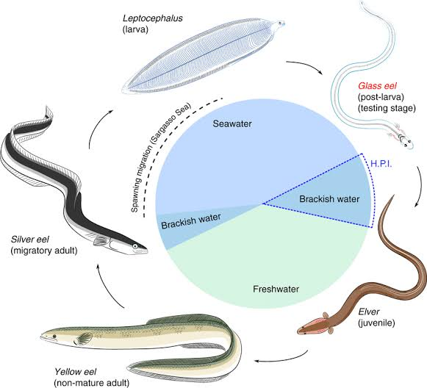
Figure 1: Life cycle of anguillid eels (source Cresci et al., 2019)
The early stage of the eel, the leptocephalus, is a distinctive larva with a highly laterally compressed and almost transparent body which primarily occurs in marine waters (Miller, 2009). From their spawning areas, leptocephali are transported along ocean currents at the continental shelf (Arai et al., 2016; Miller et al., 2018; Miller and Mc Cleave, 2018). Leptocephalus appear transparent in colour, mimicking gelatinous zooplankton, thus low incidence of predation at sea (Miller et al., 2018; Miller and Mc Cleave, 2018). Before arrival at estuaries leptocephali metamorphosize into transparent glass eels. Recruitment of glass eels into the estuaries from the sea is referred to as inshore migration (Arai et al., 2020). Prior to inshore migration glass eels undergo metamorphosis, developing of most organs such as intestine, gills and kidneys; as well as muscles and bones development (Otake, 2003). Upon entry into the estuary glass eels transitions its osmoregulatory system from one that eliminates excess salt and conserves water to the one where the whole reverse applies, so as to achieve homeostasis (Harrison et al., 2014).
At the stage of initial arrival in the estuary from the sea, glass eels are still almost completely transparent with no external pigmentation except a small rosette of pigment present around the top of the cranium (Strubberg, 1913; Arai, 2015). Ideally, glass eels carry out their migration into estuaries and then into fresh water (Dekker, 2002). Progressively, pigmentation darkens as the glass eels actively swim upstream transitioning into elvers, four to eight months after hatching to grow in freshwater habitats (Dekker, 2002; Harrison et al., 2014). After ascending upstream further into freshwater as elvers, the subsequent growing phase is termed as yellow eel (immature) which lives in freshwater habitats (Harrison et al., 2014). The timespan of this stage spans from a minimum of 7 years to a maximum of 50 years depending on factors such as species, sex, and geographic location (Hanzen et al., 2019). The subsequent life stage from yellow eel is referred to as the silver eel. During the metamorphosis of yellow eels to silver eels, the ventral side of the body becomes more, whiter and reflective, their gonads develop, and their eyes increase in diameter by approximately 50% (Okamura et al., 2007). This metamorphosis coincides with the initiation of their downstream migration towards the marine habitat, where they ultimately reach the spawning grounds and subsequently die (Harrison et al., 2014; Arai, 2015). However, the silver eel migration period is one of the life stages that is still poorly understood (Okamura et al., 2007; Harrison et al., 2014).

Oceanic migration and spawning of anguillid eels
Temperate anguillid eels are characterized by clearly defined, spawning and recruiting seasons (Tsukamoto, 2009; Robinet et al., 2003; Arai and Siti, 2016). The spawning migration of temperate anguillid eels generally occurs during autumn months between August and December in the Northern Hemisphere and between February and May in the Southern Hemisphere, except in a case of the prolonged downstream migration activity between April and December with high temporal variation in the European eel in north eastern Germany (Tsukamoto, 2009; Arai and Siti, 2016). All four tropical anguillid eel species share a similar spawning area located east of Madagascar (Jespersen, 1942). However, according to Pous et al. (2010), tropical anguillid eels have different spawning areas closely linked through migratory routes to their recruitment sites.
Anguilla mossambica is thought to breed east of Madagascar but moves southwest on its way to the Mozambique coast and South African rivers, while their leptocephali are then transported southwards by the South Equatorial Current (SEC) with migration distances in the order of 1,000 to 2,000 km (Réveillac et al., 2009). A study by Jubb, (1961) showed that that juvenile of A. mossambica reach the mainland coast between latitude 21°S at the border between Mozambique and Tanzania and 31°S southern coast of KwaZulu-Natal in South Africa. Another study states that their leptocephali are transported southwards by the South Equatorial Current (SEC) with migration distances in the order of 1,000 to 2,000 km (Réveillac et al., 2009)

Anguilla bicolor has two potential spawning area southwest of Sumatra (Jespersen, 1942; Arai et al., 1999) and northeast of Madagascar (Robinet and Feunteun, 2002). Even though its presence may be seen in eastward flowing rivers of east Africa, the species has not been recorded in Kenyan rivers (Pike et al., 2019a). Glass eel, elvers and post-elvers of A bengalensis have been recorded to follow a northern migration route around Madagascar reaching the coast north of latitude 20°S. (Robinnet et al., 2007; Réveillac et al., 2009;). According to Robinnet et al. (2007), A. marmorata has the widest distribution in the world and has been reported together with A mossambica in the islands of Mauritius and Réunion (Robinnet et al., 2007; Hanzen et al., 2019). Jespersen’s, (1942) hypothesized that the migration pattern of A. mossambica and A. marmorata larvae are transported around the southern tip of Madagascar.

Upstream migration
While the catadromous life cycle of anguillid eels show that they migrate between marine and freshwater habitats, some studies have documented that not all species of anguillid eels migrate upstream into freshwater habitats, but rather display facultative catadromy completing their life in estuarine habitats (Tsukamoto and Arai, 2001; Arai et al., 2013; Harrison et al., 2014). Recent studies on otolith chemistry show that anguillid eels have more adaptable life histories than previously studied (Tsukamoto et al., 2002; Chino and Arai, 2010; Arai and Chino, 2012). Anguillid eels have been reported to exhibit facultative catadromy by either migrating between rivers and estuarine habitats or migrating between seawater and estuarine habitats of multiple freshwater rivers (Hanzen, 2020; Harrison et al., 2014). Studies on otolith microchemistry of temperate anguillid eels have also shown that, some yellow and silver stages, spend their entire life history in the ocean and never migrate into freshwaters (Arai et al., 2013).
According to the migratory life history of A mossambica and A marmorata, otolith ratio of Strontium:Calcium ratios of sampled by Lin et al. (2012) from South African rivers, showed that after inshore migration as glass eels, elvers of both species resided in estuarine habitats awaiting favourable river flow conditions during the wet season in preparation for upstream migration. However, if the river flow is insufficient for upstream migration, elvers will most likely leave and travel along the coast in search of favourable habitats as an alternative option (Lin et al., 2012).
Facultative catadromy can be explained by estuarine habitats being able to provide a significant environment for feeding and rearing from their entry as glass eels to their escapement at silver eel life stage (Lin et al., 2012; Arai et al., 2013; Harrison et al., 2014). However, information on facultative catadromy has only been obtained for temperate anguillid eels and little is known about the utilization of environmental habitats by tropical anguillid eels in East African rivers (Hanzen et al., 2020; Arai et al., 2013).

Factors influencing the occurrence of juvenile anguillids
Anguillid eels inhabits a diverse array of aquatic habitats throughout their complex lifecycle, including the open sea, coastal shelves, estuaries, and freshwater ecosystems (Righton et al., 2021). The underlying processes that regulate the migration of eels once they have reached the physiological stage, ready to migrate, remain a subject of ongoing investigation. Nonetheless, factors that are known to be associated with habitat selection by eels include abiotic characteristics such as: water depth, temperature, salinity, substrate type, water flow, oxygen levels, vegetation cover; and biotic characteristics such prey availability, predation threat, and presence of other eels (Silberschneider et al., 2001; Righton et al., 2021). Majority of these variables have mostly been described for temperate juvenile anguillid eels as compared to tropical juvenile anguillid eels (Arai et al., 2020). What is mostly documented within the WIO is information on the recruitment and species composition of tropical juvenile eels within estuaries (Sugeha et al., 2001; Aoyama et al., 2015).
Anguillid eels respond to physicochemical properties such as temperature and salinity during migration and spawning (Schabetsberger et al., 2016). For instance, a minimum dissolved oxygen concentration of 5 mg/L is documented to be ideal for nursery culture of glass eels, as juvenile eels cannot survive in oxygen concentrations below 2 mg/L (Cuvin et al., 2019). While temperature is a critical factor in the survival, feeding, and growth of fish species, affecting food passage, enzyme activity, and metabolic response rate (Linton et al., 2007; Briand, 2009; Harrison et al., 2014). In the Philippines tropical glass eels have been successfully reared in temperatures ranging from 19 to 30°C without any signs of temperature stress (Cuvin et al., 2019). Juveniles of A. marmorata have been documented to be sensitive to low water temperature and have an optimal growth temperature of 27.6 °C (Luo et al., 2013). A study by (Arai et al., 2020) reported presence of A. bengalensis specimens in upstream locations with temperatures ranging from 23.6 to 28.1 °C. However, due to moderate temperatures being continuous year-round and lack identifiable seasons in the tropics, water temperature may not be a factor in tropical glass eels' inshore migration (Cuvin et al., 2019; Arai et al., 2020).
Inshore migration of glass eels is influenced by light intensity (Arai et al., 2020) As documented by Laffaille, (2007), light intensity plays a role in glass eel migration, showing an increase in migration activity in the dark during the first hour of darkness, during which they move closer to the surface as compared to their activity during the day (Bardonnet et al., 2003; Laffaille, 2007). However, this variable is still debatable, since Bardonnet et al. (2005) reported that light intensity has no inﬂuence on glass eel migration. While studying upstream migration of temperate species of glass eels in the Waikato River in New Zealand, Jellyman, (1979) suggested that light has no influence on A. australis and A. dieffenbachii glass eels after observing that they migrated both during the day and night (Prouzet et al., 2009; Arai et al., 2020). Laffaille, (2007) observed glass eels shifted towards the bottom of the bed when light intensity was high and were most actively moving and abundant at the bottom where light intensity was to a much lower degree. Similarly, experimented in an aquarium glass eels of A. japonica were observed to burrow in the sand during daytime (Dou and Tsukamoto, 2003)
A correlation between light and lunar cycle highlights that glass eels remain in much deeper water columns during the full moon attributed to the high light intensity at that lunar period. A study by Sugeha et al. (2001) in the Poigar estuary recorded fewer glass eels during the full moon and higher glass eels collected during the new moon as compared to the waxing and waning moons. Arai et al. (2020) reported both lunar and semilunar periodicity of inshore migration by glass eels, with high number of glass eels observed to recruit during the new moon phase as compared to the full moon phase. Thereby, high moonlight intensity does play a role in influencing both inshore and upstream migration. However, it is debated that lunar effect has no influence in highly turbid estuaries (Harrison et al., 2014). Turbid conditions reduce light penetration thus making lunar periods have no significant influence on migrating juvenile anguillids. Additionally, high turbidity may decrease predation rates guaranteeing higher survival and successful upstream migration (Lunt and Smee, 2020).

CHAPTER THREE

MATERIALS AND METHODS

Study area
The study was conducted in the Sabaki Estuary, located 10km north of Malindi town which lies between longitude: 3.2ºS and latitude: 40.15º, occupying approximately 250 ha (Abuodha, 1998; Houte-Howes, 2005). The Sabaki Estuary arises from the Athi River, the second largest river in Kenya; which discharges its waters into the Indian Ocean, north of Malindi along the Kenya coastline, near the Malindi–Watamu reef complex (Katwijik et al., 1993; Marwik et al., 2014).
The estuary is made up of two main zones; an intertidal muddy area and a main tidal channel, characterized by spring and neap tide, seasonal tidal effects (Kitheka et al., 2015; Kitheka et al., 2016). During each tidal cycle, the estuary experiences alternating low (Figure 2) and high waters with an average shallow depth of 3 m (Kitheka et al., 2015; Kitheka et al., 2016). As a result, seawater which does not obtrude permanently into the estuary is flushed out during each tidal cycle (Kitheka et al., 2016). The intertidal muddy area is characterized by mudflats of dark brown clay and mud deposits colonized by a variety of mangrove trees (Kitheka et al., 2013; Kitheka et al., 2015). Occurring mostly in the lower region of the estuary, the mangrove species present are Aviccenia marina, Rhizophora mucronata, Bruguiera gymnorrhiza, Xylocarpus granatun and Ceriops tagal (Kitheka et al., 2013).

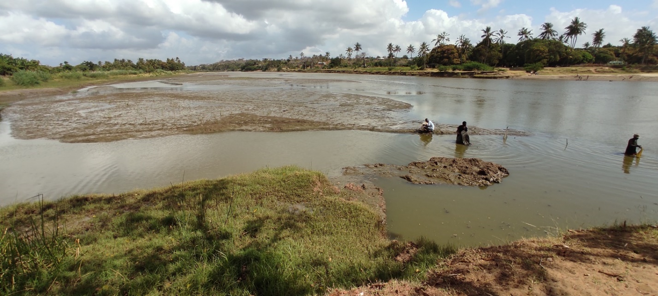
Figure 2: A photograph of the Sabaki Estuary taken during the low tide (Photo by Gitonga 2021)
Sabaki Estuary experiences a tropical monsoon climate with two distinct rainfall seasons; the ‘Kaskazi’ or Northeast Monsoon (NEM) and the ‘Kusi’ or Southeast Monsoon (SEM) season (Houte-Howe, 2005; Kitheka et al., 2013). The NEM season occurs between October and March, characterized by calm and warm sea and less rains, whereas the SEM season occurs between March and September characterized by rough and cool sea, more rains, stronger winds and lower temperatures (Kitheka et al., 2013; Kitheka et al., 2015). NEM is associated with the short rains with the peak rainfall occurring in November whereas, SEM is associated with the long rains occurring between March and June with peak rainfall in April in the hinterland and May along the coast (Kitheka, 2013; Kitheka et al.,2015; Kitheka, 2016).
Artisanal fishers within the estuary employ traditional small dugout canoes, locally referred to as such as mtumbwi, hori, ngalawa and dau (Fulanda et al., 2011) and traditional fishing gears, due to their low-cost nature, making them easil accessibale to fishers (McClanahan & Mangi, 2004; Munga et al., 2014). Dominant fishing gears used in the estuary range from traditional traps such as malema basket traps, to modern gears and tidal weirs or hand lines and long lines, as well as drift and gillnets (Fulanda et al., 2011; Munga et al., 2016). However, majority of artisanal fishers in the estuary are mostly inclined to fishing at the seaward side ﬁshing grounds (Munga et al., 2012).
Fish species exploited by local artisanal fishers within the estuary include members of the families Protopteridae (lungﬁshes), Clariidae (catﬁshes), Cichlidae (tilapines) and several species of prawns such as Feneropenaeus indicus, Penaeus monodon, Penaeus semisulcatus, Penaeus japonicus and Metapenaeus monoceros (Fulanda et al., 2011; Munga et al., 2012; Munga et al., 2013; Munga et al., 2016). The estuary also serves as bird sanctuary for feeding grounds and roosting sites for large numbers of gulls and terns, non-breeding Lesser Flamingos Phoeniconaias minor and some rarer species such as Broad-billed Sandpiper Limicola falcinellus (Kitheka et al., 2013; Houte-Howes, 2005).

Sampling design and data collection
In the present study, the estuary was divided into four sampling locations; SBE1, SBE2, SBE3 and SB4 (Figure 3). SBE4 (3°09'11"S 40°07'40"E) was about 1.5 km proximate to the mouth. SBE1 (3°08'58"S 40°07'13"E), SBE2 (3°08'57"S 40°07'19"E) and SBE3 (3°08'52"S 40°07'28"E) were at distances 0.5 km from each other upstream of SBE4. SBE1, SBE2 and SBE4 are characterized by vegetation edges at the banks with Prosopis juliflora trees being the most predominant with small scale agricultural farming and irrigation occurring around the estuary banks. The banks at SBE3 were characterized by rocky and muddy biotope. 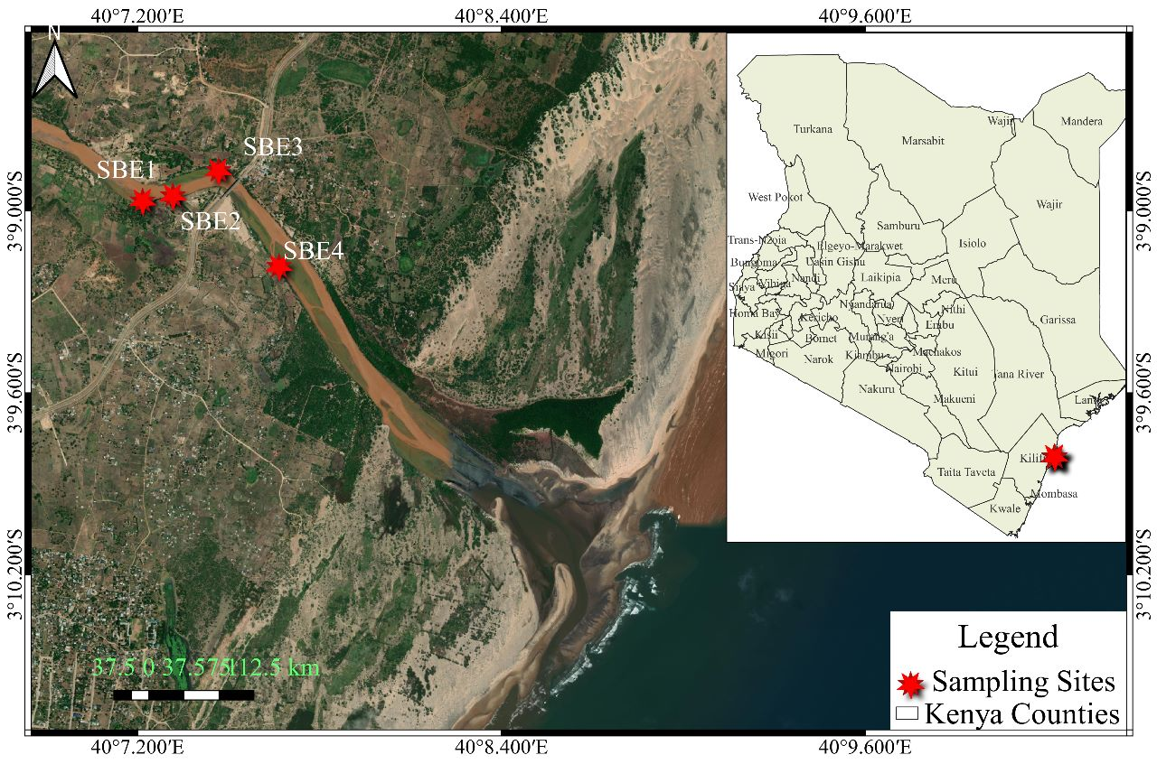Figure 3: A map showing sampling stations marked in red along the Sabaki Estuary

Capture of juvenile anguillid eels
Juvenile anguillid eels were caught using very fine mesh glass eel fyke nets, which are designed for commercial glass eel fisheries in Australia (T&L netmaking, Mooroolbark, Australia). Sampling was done monthly, over a period of 5 consecutive nights by setting 4 fyke nets at each of the four sampling locations. Fyke nets were deployed at noon, during low tide and installed using poles anchored firmly into the substrate, with the cod end secured to vegetation and the two wings facing seaward (Figure 4) in two distinctive habitats characterized by vegetation edges and rocky/muddy biotope. Global Positioning System (GPS) of each glass eel fyke net were recorded.
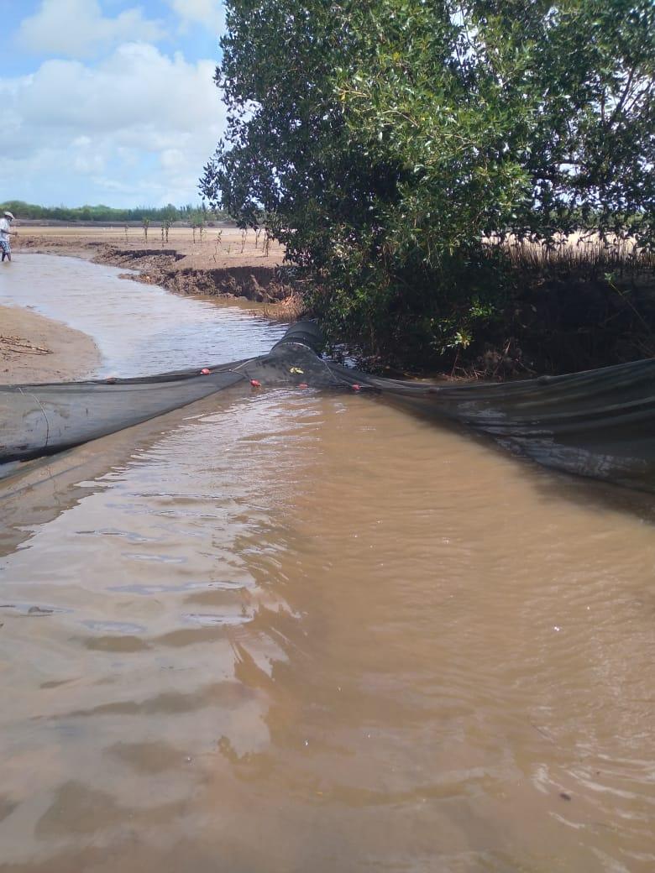
Figure 4: Photograph of a glass eel fyke net anchored along the bank of the Sabaki Estuary facing seaward, during low tide (Photo by Gitonga, 2021)
The nets were checked at dawn and the catch was transferred to a bucket containing water drawn from the estuary at each sampling site.

Sorting, identification and measurement of the catch
The contents in the bucket were sieved through 500 mm mesh net and the catch sorted to species. Fish (except juvenile anguillid eels) were measured for total and standard length (to the nearest 0.1 cm) on a fish length measuring board and weighed to the nearest 0.1g on an electronic top loading balance. Juvenile anguillid eels captured were measured for total length only (to the nearest 0.1 cm) and those without external body pigmentation classified as glass eels while those with pigmentation were classified as elvers. Juvenile anguillid samples were then stored in sampling bottles, in 99% absolute ethanol and transported to Kenya Marine Fisheries Research Institute (KEMFRI) laboratories for further morphological characterization, to enable species identification.
3.5 Laboratory processing of juvenile eel samples
In the laboratory, juvenile anguillid eels were identified to species level by observing their tail pigmentation under a microscope (Stemi 305, Carl Zeiss Microscopy GmbH, Germany) at x 2 magnification according to Revelliac et al. (2009) protocol (see Appendix 2) and individual photographs taken using ZEN imaging software (Carl Zeiss Microscopy GmbH). Eye diameter recorded as left eye diameter (LED) and right eye diameter (RED) together with fin difference index (FDI), which is the distance between the dorsal fin (DF) to the anal fin (AF) (see Appendix 3), were measured in micrometres µm, under a microscope using ZEN software at x 2 magnification for all glass eels and x 1 magnification for all elvers. All morphometrics were recorded in a data sheet (Appendix 1).

Physiochemical parameters and lunar cycle data
After retrieval of catch from fyke nets, data on physicochemical parameters were obtained at each sampling location using a hand-held water quality meter. The water quality meter was lowered in water adjacent to the deployed sampling fyke net (Figure 5) and the readings recorded. (Appendix 1).
Lunar phases were categorized into five groups, which were full moon, waning gibbous, last quarter moon, first quarter moon, waning crescent moon and new moon. Daily moon phase data as well, moonset and moon rising timings were obtained from Vitalii, (2019) software application and data recorded.
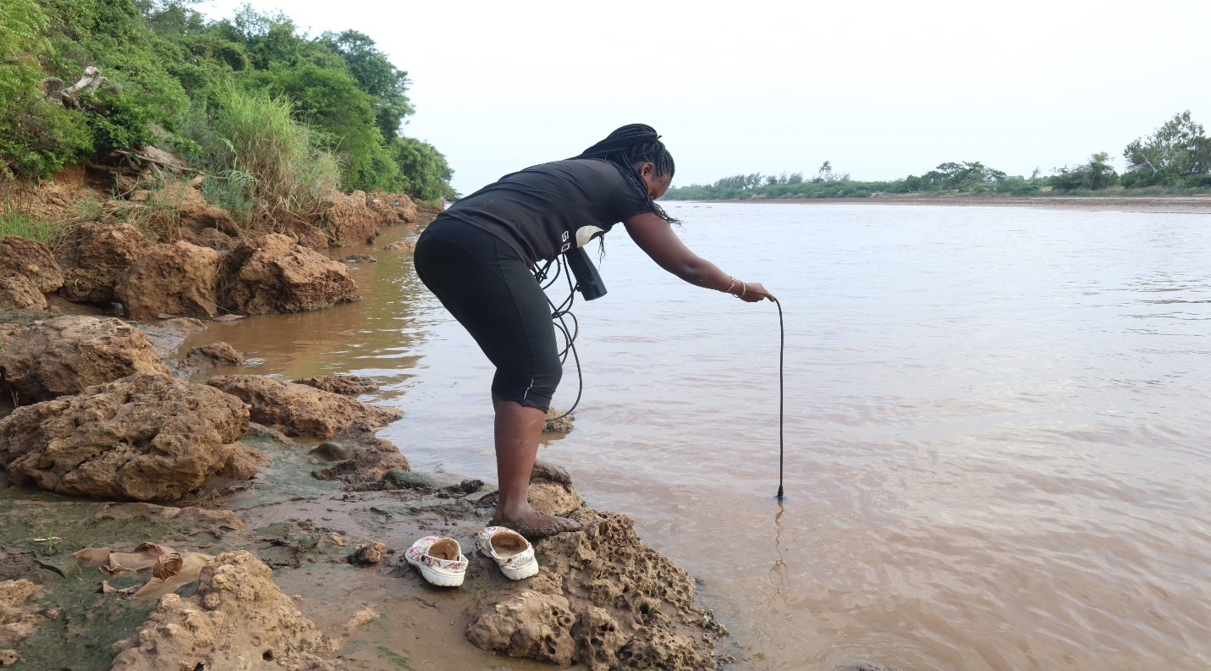
Figure 5: A photograph displaying the measuring physiochemical parameter next to an anchored glass eel fyke net (Photo by Gitonga, 2021).

Data analyses

Data preparation
Data were recorded in field note books and later entered into an Excel . Data collected was subjected to both descriptive and inferential statistics after cleaning and tidying.

Descriptive statistics
Total number of individuals caught, their total lengths, standard lengths and average weight were illustrated in summary tables and figures. Species morphometric were recorded in tables which included, different measurements illustrated in this study. All the measurements were illustrated in tables with their means and standard deviations. Variations in morphometry across the different seasons, lunar phases and seasons were illustrated using figures.

Inferential statistics
Inferential statistics included the determination of significant differences in morphometry of the caught individuals’ species across different sites, lunar phases and seasons. One-way analysis of variance was utilized in determining the significance of morphometric differences. Fin difference index (FDI), distance between the verticals from beginning of the dorsal fin to the anal fin (Z) relative to the total length (TL) (Ege, 1939), was calculated as follows:
FDI =¼ 100 Z T_{L-1}
Chi-square test of association was utilized in determining the presence or absence of association between species of juvenile anguillids caught and the sites in which they were caught, lunar phases and seasons of occurrence. Catch per unit effort (CPUE) that acts as an index of abundance of living organisms in ecosystems was utilized to determine the effort required to catch different species of juvenile anguillids in relation to, catch per trap per day.
One way analysis of variance was utilized in determining the significance of differences in the catch per unit effort associated with different species. Three diversity indices were used to determine the diversity of species across sampling sites, sampling seasons and different phases of the moon; the indices used included the Shannon weaver diversity index, Simpson’s and inverse Simpson’s diversity index. The indices were fairly consisted across the grouping variables which included the seasons, moon phase and seasons.
All tests of significance used a 0.05 alpha level or a 95% confidence interval.

CHAPTER FOUR

RESULTS

Summary of species caught
Species belonging to 10 families were caught during the study. Since the family Anguillidae family was the target interest of study, 9 different families were caught as by-catch. Tank gobby (Glossogobius giuris Hamilton, 1822), dominated the catch with 947 individuals and had an average total length of 14 cm and a standard length of 10 cm while weighing an average of 23 grams. Sabaki tilapia (Oreochromis spirulus spirulus Gunther, 1894) followed distantly in abundance with 118 individuals with an average weight of 26 grams with a standard length and total length of 12 cm and 15 cm respectively. Anguillidae family came third with 50 individuals from A. bengalensis species. Anguilla bengalensis had an average total length of 5.5 cm weighing 5 grams. Mozambique tilapia (Oreochromis mossambicus Peters,1852) followed with 47 individuals, then the snake eel with 45 individuals. Snake eels (Pisonodophis boro Hamilton 1822) were the longest having an average total length of 108 cm weighing 71 grams. Table 1 illustrates the summary results of the caught species. The target species belonging to Anguillidae family were A. bengalensis which led with 50 individuals, followed A. mossambica with 23 individuals and A. marmorata with 2 individuals.
Table 1: Summary of species composition caught in the study area
Species | Family | English Name | Local name | Individual counts | Total Length | Standard Length | Weight (g)
Glossogobius giuris | Gobiidae | Tank goby | Jumburu | 947 | 14.55±3.11 | 10.01±0.99 | 23.26±3.18
Oreochromis spirulus spirulus | Cichlidae | Sabaki Tilapia | Parapara | 118 | 15.36±3.19 | 12.49±2.65 | 26.64±7.42
Anguilla bengalensis | Anguillidae | Indian mottled eel | Mkunga | 50 | 5.55±0.13 | - | -
Oreochromis mossambicus | Cichlidae | Mozambique tilapia | Parapara | 47 | 16.33±3.69 | 11.79±2.68 | 15.88±3.01
Pisonodophis boro | Ophichthidae | Snake eel | Mkunga nyoka | 45 | 108.7±24.97 | - | 71.35±6.14
Scylla serrata | Portunidae | Mud crab | Koe | 41 | 10.5±1.71 | 5.1±0.58 | 21.3±8.33
Bagrus docmak | Bagridae | Sudan catfish | Fume | 34 | 35.1±8.82 | 29.06±7.52 | 79±7.51
Stenogobius kenyae | Gobiidae | Africa river gobby | Black Jumburu | 25 | 69.97±8.4 | 57.04±6.62 | 17.32±6.3
Planiliza alata | Mugilidae | Diamond mullet | Mbinini | 24 | 4.26±0.17 | 4.97±1.34 | 2.67±1.12
Anguilla mossambica | Anguillidae | African longfine eel | Mkunga | 23 | 6.52±0.57 |  | -
Otolithes ruber | Sciaenidae | Tiger tooth croaker | Gufadi | 14 | 20.22±9.6 | 16.76±8.14 | 21.69±4.75
Penaeus indicus | Penaeidae | White Shrimp | Kamba | 5 | - | - | 528.38±66.82
Anguilla marmorata | Anguillidae | Giant mottled eel | Mkunga | 2 | 5±NA | - | 5.1±NA
Barbus oxyrhynchus | Cyprinidae | Pangani barb | Karange | 1 | 124±NA | 97±NA | 19±NA
Penaeus indicus | Penaeidae | White Shrimp | prawns | 1 | - | - | 579±NA

Life stage and species occurring within the Sabaki Estuary

Life stage
A total of 76 juvenile anguillid eels were collected. The individual life stages observed to occur in the Sabaki Estuary were, glass eels, which appeared transparent in colour (Figure 6) and elvers which appeared pigmented (Figure 7). Glass eels were more abundant at 87% (n = 66) while elvers were less abundant at 13% (n = 10), Table 2.
Table 2: Results showing life stages of juvenile anguillid eels captured in the Sabaki Estuary
Anguillid life stage | N = 76
Elver | 10 (13%)
Glass eel | 66 (87%)

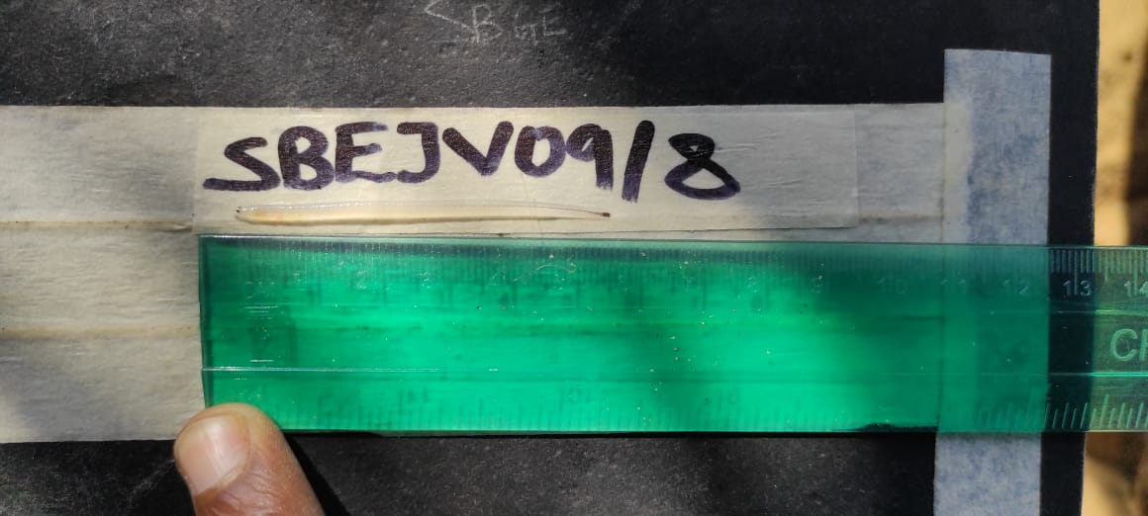
Figure 6: A photograph displaying the transparent colouration of a glass eel captured in the Sabaki Estuary, previously preserved in ethanol (Photo by Gitonga, 2021)
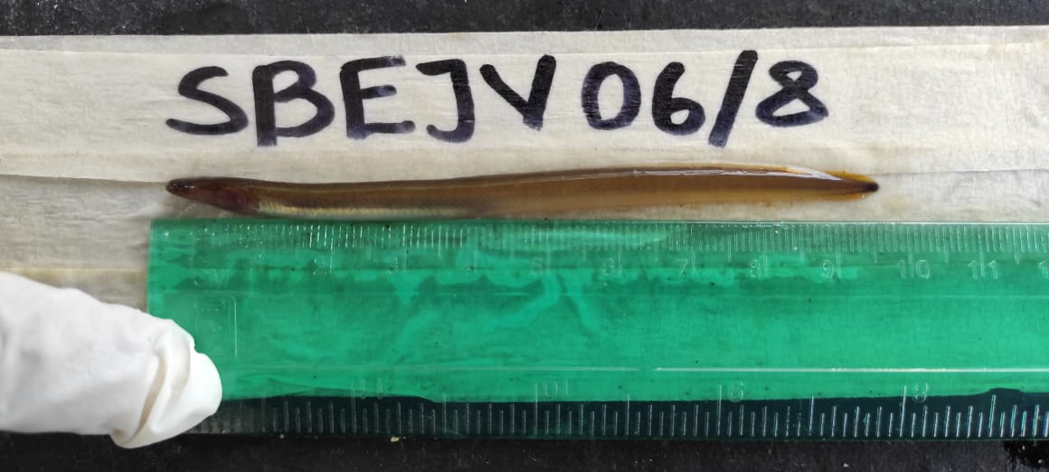
Figure 7: A photograph displaying an elver with pigmentation captured in Sabaki Estuary (Photo by Gitonga, 2021)

Species of juvenile anguillid eels captured in the Sabaki Estuary
Among the juvenile anguillid eels captured, A. bengalensis (Figure 8) was the most abundant (n = 50). This was followed by A. mossambica (Figure 9), with 23 individuals while only 3 individuals of A. marmorata (Figure 10), were captured as presented in Table 3.
Table 3: Species of anguillid eels caught in the Sabaki Estuary
Species | Local name | Number of individuals
A. bengalensis | Mkunga | 50
A. mossambica | Mkunga | 23
A. marmorata | Mkunga | 3

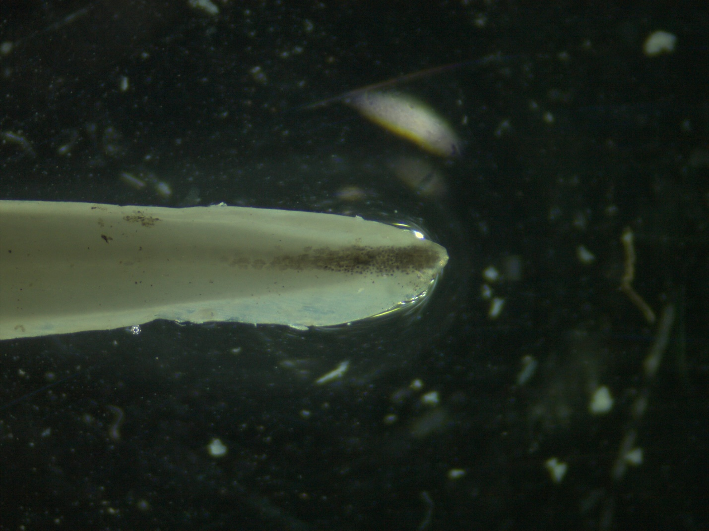
SBEJV22/8 (Anguilla bengalensis)
Figure 8: A photograph showing tail pigmentation of A. bengalensis glass eel taken by Stemi 305, Carl Zeis microscope GmbH, Germany using ZEN imaging software at x 2 magnification

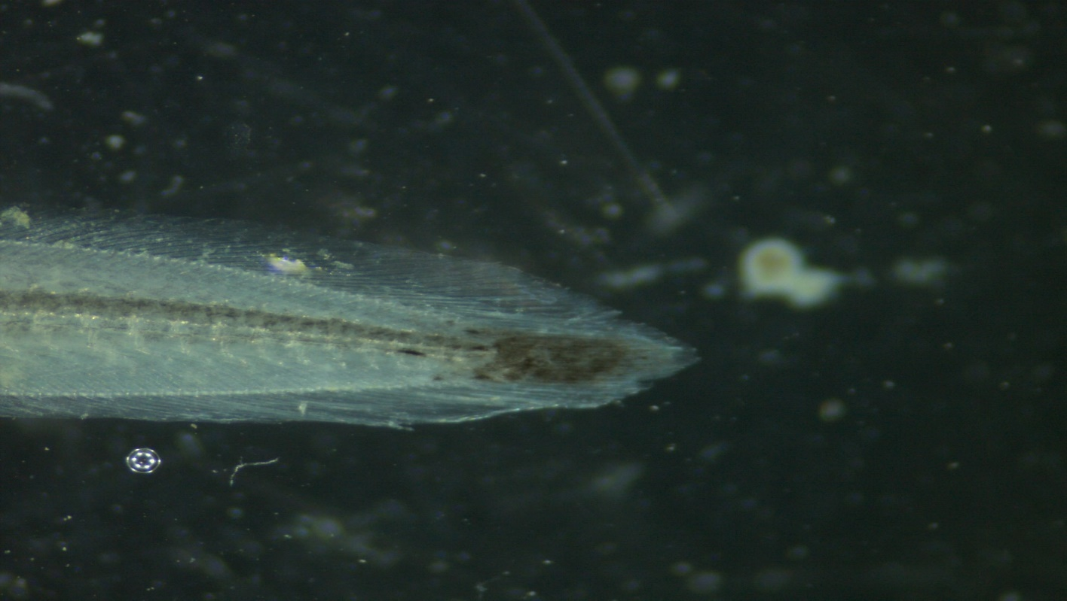
SBEJV05/8 (Anguilla mossambica)
Figure 9: A photograph showing tail pigmentation of A. mossambica glass eel taken by Stemi 305, Carl Zeis microscope GmbH, Germany using ZEN imaging software at x 2 magnification.
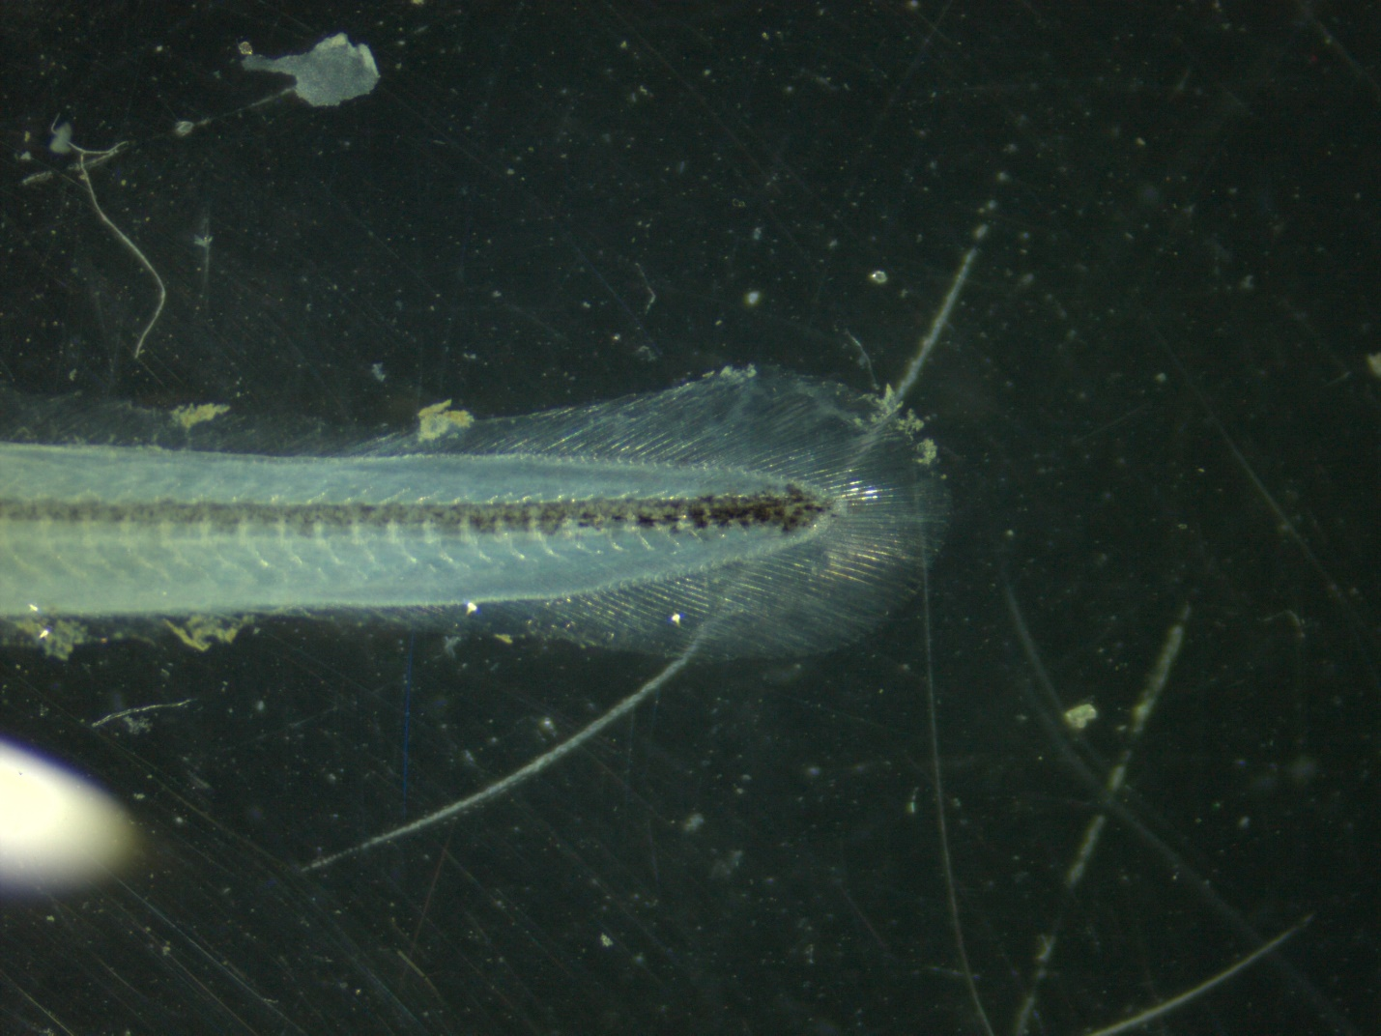
SBEJV04/8 (Anguilla marmorata)
Figure 10: A photograph showing tail pigmentation of A. marmorata glass eel taken by Stemi 305, Carl Zeis microscope GmbH, Germany using ZEN imaging software at x 2 magnification.
Most of the juvenile anguillid eels caught were glass eels (Table 4). Only A. mossambica and A. bengalensis species had elvers. Anguilla bengalensis were the most abundant with 52 individuals, with 50 being glass eels and 2 elvers. This was followed by A. mossambica with 22 individuals where, 15 were glass eels and 8 were elvers. Only two A. marmorata were caught during this study.
Table 4: Life Stages of juvenile anguillid species captured in the Sabaki Estuary
Species | Stage | Number of Individuals
A. bengalensis | Glass eel | 50
A. mossambica | Glass eel | 14
A. mossambica | Elver | 8
A. bengalensis | Elver | 2
A. marmorata | Glass eel | 2

Re-organize to show meaningful information much more easily as shown below
Table 4: Number of glass eels and elvers of the three species of anguilid eels sampled in Sabaki estuary during the study
Species | Life stage |  | Total
Species | Glass Eel | Elver | Total
A. bengalensis | 50 | 2 | 52
A. mossambica | 14 | 8 | 22
A. marmorata | 2 | 0 | 2
Total | 66 | 10 | 76

Juvenile anguillid eels morphometrics
Morphometric results showed that, A. mossambica had the highest average total length of 6.29 cm followed by A. bengalensis with an average total length of 5.43cm while A. marmorata registered the shortest average total length of 5.2 cm (Table 5). One-way analysis of variance (ANOVA) showed that the differences in total length among the three species were statistically significant (ANOVA, p = 0.007). Fin morphometrics showed that, A. mossambica had the largest average DF to AF length with 249mm followed by A. marmorata with 125mm while A. bengalensis had the shortest average DF to AF length with 123mm. The mean differences in DF to AF lengths were statistically significant among the three different species as tested by the ANOVA results that showed statistical significance at critical level of 0.05 (ANOVA, p = 0.008). Results of FDI calculating the length between dorsal and dorsal fin relative to the total length (LT) did not conform to Ege, (1939) taxonomic key. FDI for all for all 76 specimens were < 1% (Appendix 4).
Both eye and fin morphometric measurements showed a similar trend with A. mossambica having the largest morphometric measurements followed by A. marmorata and trailed by A. bengalensis though they were not statistically significant.
Table 5: Morphometrics of juvenile anguillid species occurring in the Sabaki Estuary
Morphometry | A. bengalensis | A. marmorata | A. mossambica | p-value
TL (cm) | 5.43 ± 0.53 | 5.20 ± 0.28 | 6.29 ± 1.81 | 0.007
DF to AF (mm) | 123 ± 42 | 125 ± 8 | 249 ± 282 | 0.008
LED (mm) | 63 ± 8 | 64 ± 9 | 82 ± 73 | 0.2
RED (mm) | 60 ± 9 | 63 ± 5 | 80 ± 73 | 0.14

Temporal variability

Species composition of juvenile anguillid eels captured across the sampling months
Majority of the juvenile anguillids were caught during the month of August 67% (n=51), followed distantly by the month of November 14% (n=11) while the least number of individuals were caught in the months of July and September 2.6% (n=2) respectively (Figure 11). A chi-square test of association indicated lack of significant association between individual species caught and months of the study since the p value was greater than 0.05 (p = 0.2) (Table 6).

Table 6: Distribution of juvenile anguillid species captured across sampling months The reader would want to know something about the percentages in the tables
Table 6. Number of juveniles anguilid eels caught during each monthly sampling
 | Month
 | August | July | November | October | September | January | Total | p-value¹
Species |  |  |  |  |  |  |  | 0.2
A. bengalensis | 31 (41%) | 1 (1.3%) | 9 (12%) | 10 (13%) | 1 (1.3%) | 0 (0%) | 52 (68%)
A. marmorata | 2 (2.6%) | 0 (0%) | 0 (0%) | 0 (0%) | 0 (0%) | 0 (0%) | 2 (2.6%)
A. mossambica | 18 (24%) | 1 (1.3%) | 2 (2.6%) | 0 (0%) | 1 (1.3%) | 0 (0%) | 22 (29%)
Total | 51 (67%) | 2 (2.6%) | 11 (14%) | 10 (13%) | 2 (2.6%) | 0 (0%) | 76 (100%)

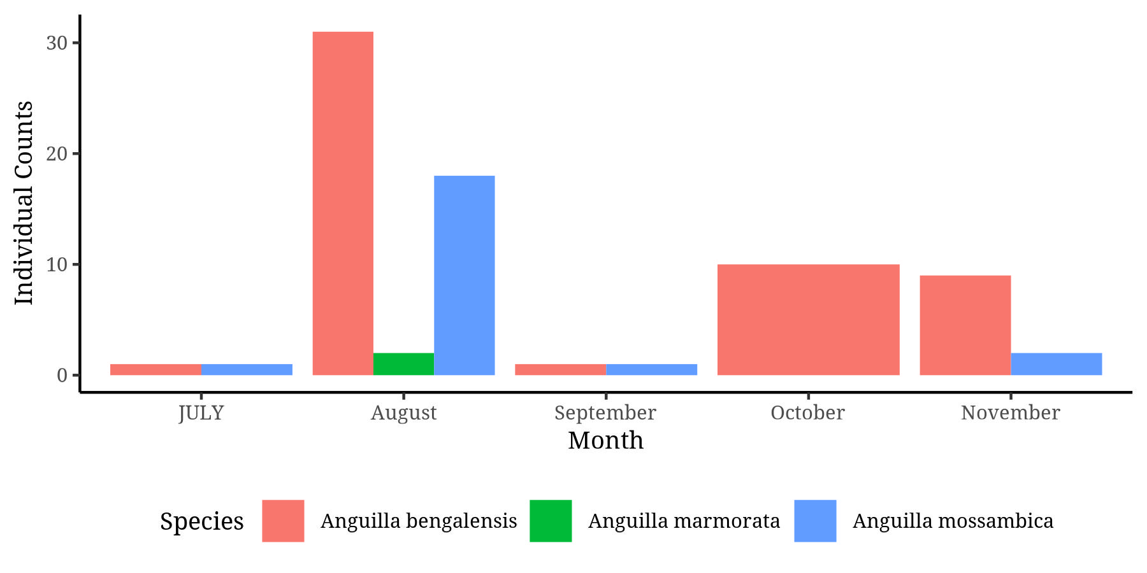
Figure 11: A bar graph showing the distribution of juvenile anguillid eel species across months sampled

Species composition of juvenile anguillid eels captured across seasons
Majority of juveniles, 70% (n=53) were caught during the wet season while only 30% (n=23) were caught in the dry season (Figure 12). What of glass eels and elvers, in relation to seasonality??

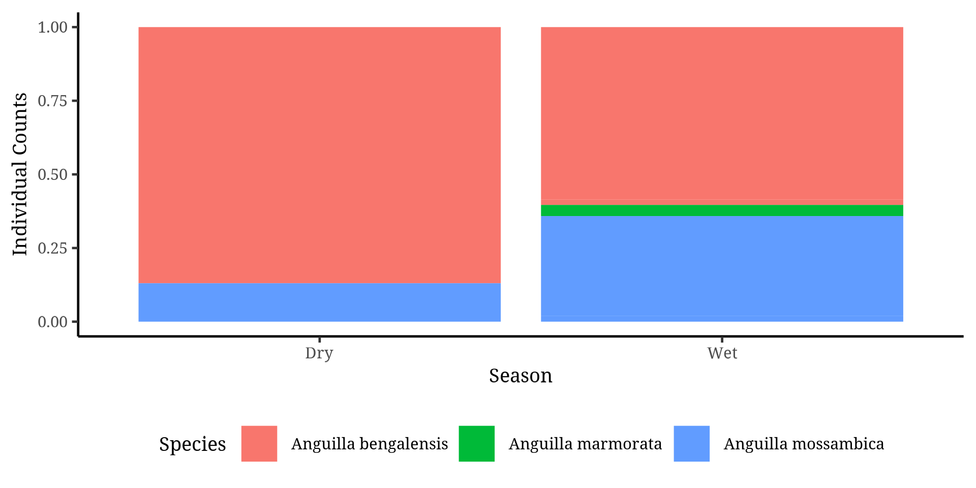
Figure 12: A stacked bar graph showing variations in species composition of juvenile anguillid eels across seasons
Anguilla marmorata were only caught during the wet season. The chi-square test of association indicated that there was no significant association between seasonality and the species caught (p = 0.06) (Table 7).

Table 7: Distribution of juvenile anguillid eel species across different seasons
 | Season
 | Dry | Wet | Total | p-value¹
Species |  |  |  | 0.060
A. bengalensis | 20 (26%) | 32 (42%) | 52 (68%)
A. marmorata | 0 (0%) | 2 (2.6%) | 2 (2.6%)
A. mossambica | 3 (3.9%) | 19 (25%) | 22 (29%)
Total | 23 (30%) | 53 (70%) | 76 (100%)

Species diversity of juvenile anguillid eels across seasons
Results of Shannon weaver, Simpson’s and inverse Simpson’s diversity index showed that diversity of caught juvenile anguillid eel species was higher in the dry season compared with the wet season (Table 8).
Table 8: Species diversity of juvenile anguillids across sampled seasons
 | Ecological Diversity Indices
Season | Shannon | Simpson | Inverse Simpson
Wet | 1.213436 | 0.4642996 | 1.866715
Dry | 1.260849 | 0.5633560 | 2.290195

Environmental influence on occurrence of juvenile anguillid eels

Association between juvenile anguillid eel species caught across habitat
A chi-square test of association was used to determine whether there existed an association between habitat and juvenile anguillid species caught. Majority of juvenile anguillid eels were caught in vegetation edges 87% (n=66) while on 13% (n=10) of anguillid species were caught in rocky and muddy areas (Figure 13). In addition, the two A. marmorata individuals were only caught among vegetation edges. Chi-square test of association indicated that the juvenile anguillid eels caught were independent of the biotope (p=0.4), (Table 9).
Table 9: Species distribution sampled two habitats characterized by vegetative and rock/muddy biotopes
 | Habitat
 | Rocky/Muddy | Vegetation edges | Total | p-value¹
Species |  |  |  | 0.4
A. bengalensis | 5 (6.6%) | 47 (62%) | 52 (68%)
A. marmorata | 0 (0%) | 2 (2.6%) | 2 (2.6%)
A. mossambica | 5 (6.6%) | 17 (22%) | 22 (29%)
Total | 10 (13%) | 66 (87%) | 76 (100%)

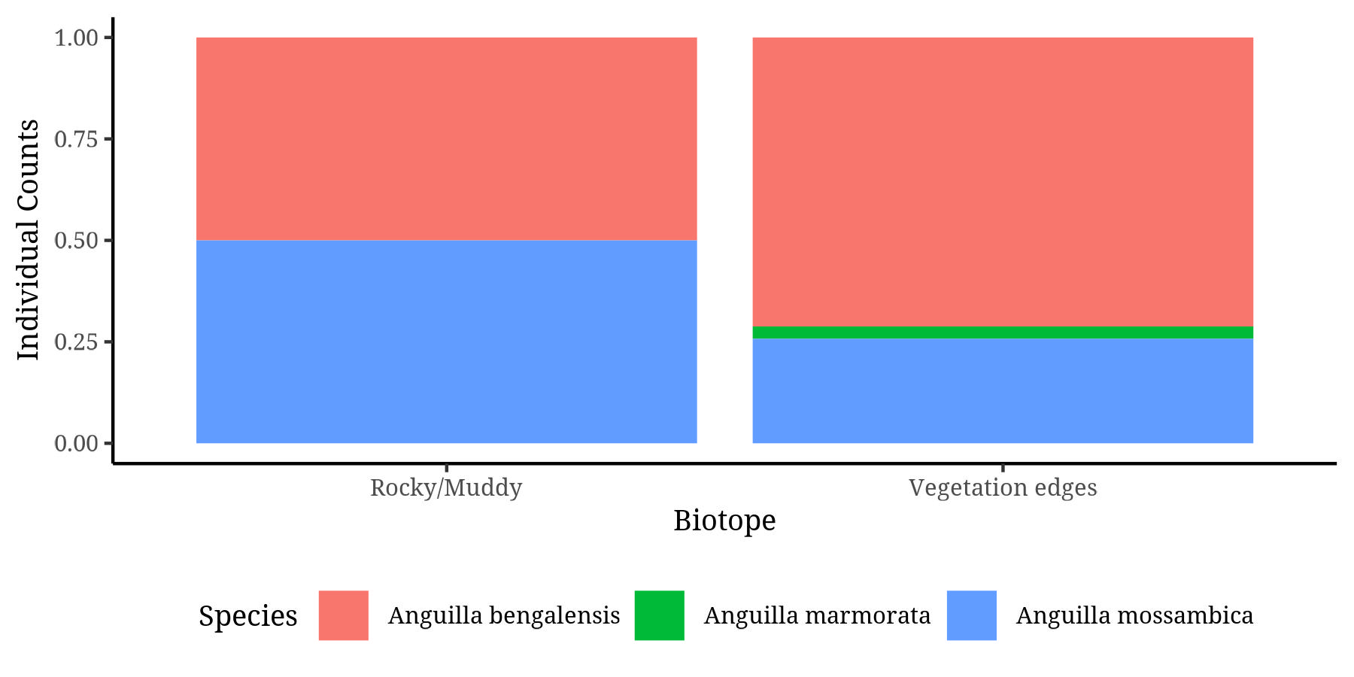
Figure 13: A stacked bar graph showing distribution of juvenile anguillid eels in two sampled habitats

Association between juvenile anguillid eels and lunar cycle
There was no significant association between the species of juvenile anguillids caught and the lunar phase, by use of a chi-square test of association (p = 0.2), (Table 10). However, majority of individuals were caught during the wanning gibbous moon phase (37%), followed by first quarter moon phase (18%) while the least individuals were caught during the full moon phase (Figure 17).
Table 10: Distribution of juvenile anguillid species captured across different phases of the lunar cycles
 | Lunar phase
 | First Quarter | Full moon | Last Quarter | Wanning Gibbous | Waxing Crescent | Total | p-value¹
Species |  |  |  |  |  |  | 0.2
A. bengalensis | 10 (13%) | 10 (13%) | 8 (11%) | 18 (24%) | 6 (7.9%) | 52 (68%)
A. marmorata | 0 (0%) | 0 (0%) | 0 (0%) | 1 (1.3%) | 1 (1.3%) | 2 (2.6%)
A. mossambica | 4 (5.3%) | 0 (0%) | 4 (5.3%) | 9 (12%) | 5 (6.6%) | 22 (29%)
Total | 14 (18%) | 10 (13%) | 12 (16%) | 28 (37%) | 12 (16%) | 76 (100%)

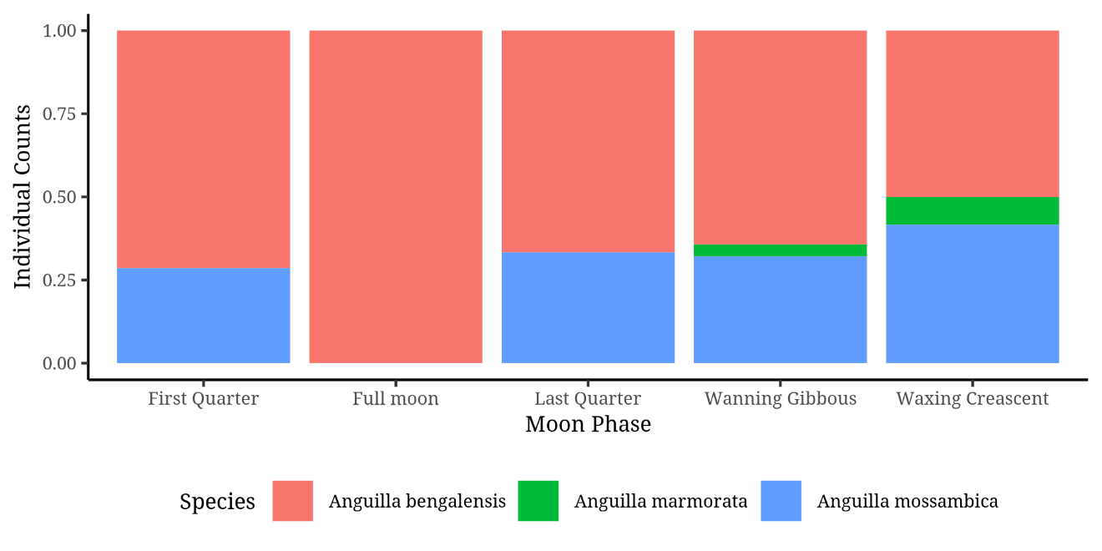
Figure 14: Stacked bar graph showing variation in juvenile anguillids distribution across lunar cycle

Species diversity across lunar phases
Results of Shannon weaver, Simpson’s and inverse Simpson’s diversity index showed that the last quarter phase of the moon experienced higher diversity followed by the full moon, then wanning gibbous, then first quarter while the waxing crescent had the lowest diversity index.
Table 11: Species diversity of juvenile anguillids captured across lunar phases
 | Ecological Diversity Indices
Lunar phase | Shannon | Simpson | Inverse Simpson
Last Quarter | 1.9000379 | 0.7588430 | 4.146676
Waxing Crescent | 0.7964051 | 0.3070939 | 1.443197
First Quarter | 1.0443225 | 0.4588839 | 1.848032
Wanning Gibbous | 1.3047799 | 0.5472546 | 2.208747
Full moon | 1.4322595 | 0.7328000 | 3.742515

Site characteristics of juvenile anguillid eels

Species distribution across sampling sites
Anguilla bengalensis dominated the catch in all sites having more than 75% of all anguillid species caught in the SBE1 and SBE2 which were closest to the estuary mouth (Figure 15). Anguilla mossambica dominated the third sampling site by having more than 50% of all individuals caught. A. marmorata was only caught in the fourth sampling site and comprised only 5% of all species caught. Anguilla bengalensis dominated the catch in site four (SBE4)
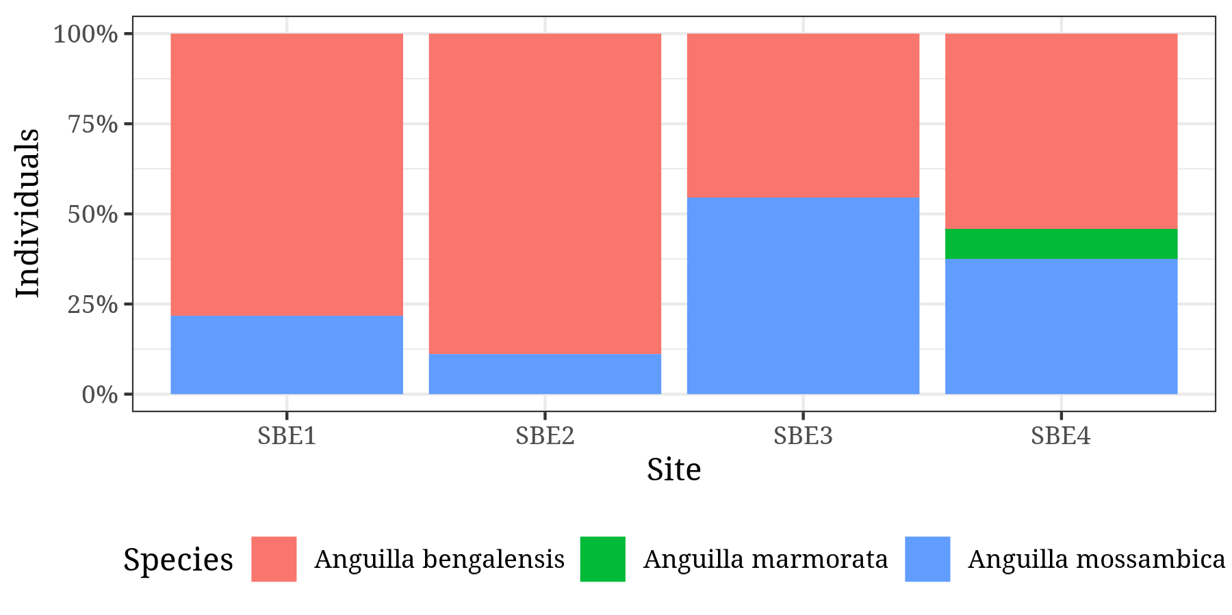
Figure 15: Bar graph showing species distribution of juvenile anguillid eels across four sampling sites; SBE1-SBE4
4.6.2 Species diversity across sampling sites
Results of Shannon weaver, Simpson’s and inverse Simpson’s diversity index showed that SBE1, the first station had the highest diversity followed by SBE2, then SBE4 while SBE3 trailed with the lowest diversity (Table 12).
Table 12: Diversity of juvenile anguillid eels across 4 sampling sites
 | Ecological Diversity Indices
Site | Shannon | Simpson | Inverse Simpson
SBE1 | 1.8947475 | 0.7576789 | 4.126756
SBE2 | 1.4892124 | 0.6344260 | 2.735424
SBE3 | 0.8700680 | 0.3525871 | 1.544609
SBE4 | 0.9421475 | 0.3839985 | 1.623373

Anguilla mossambica
There were 22 A. mossambica species caught during the study (Table 13). The majority of individuals caught were at glass eel stage 64% (n=14) while 36% (n=8) were elvers. 50% of glass eels were caught in vegetation edges while 27% of elvers were caught elvers were in vegetation edges making this biotope to be a habitat of 77% of the individuals while rocky and muddy biotopes were only habitats to 23% of A. mossambica. A chi-square test of association to determine the significance of association between life stage and biotope indicated absence of significant association (p > 0.9). The warning gibbous phase of the moon indicated the highest occurrence of A. Mossambica 41% (n=9) followed by waxing crescent phase of the moon 23% (n=5) while occurrence in the first and last quarters phases of the moon was the same at 18% (n=4) individuals. There was no association between phases of the moon and the life stage of A. mossambica (p=0.2). Seasonality did not affect the occurrence of different life stages of A. mossambica (p = 0.3). Sampling period in terms of also months did not influence the occurrence of the different stages of A. mossambica (p = 0.8).

Table 13: Occurrence of juvenile anguillids of A. mossambica across 4 sampling site characteristics
 | Local name)
 | Elver | Glass eel | Total | p-value¹
Biotope |  |  |  | >0.9
Rocky/Muddy | 2 (9.1%) | 3 (14%) | 5 (23%)
Vegetation edges | 6 (27%) | 11 (50%) | 17 (77%)
Total | 8 (36%) | 14 (64%) | 22 (100%)
Moon Phase |  |  |  | 0.2
First Quarter | 0 (0%) | 4 (18%) | 4 (18%)
Last Quarter | 3 (14%) | 1 (4.5%) | 4 (18%)
Wanning Gibbous | 4 (18%) | 5 (23%) | 9 (41%)
Waxing crescent | 1 (4.5%) | 4 (18%) | 5 (23%)
Total | 8 (36%) | 14 (64%) | 22 (100%)
Season |  |  |  | 0.3
Dry | 0 (0%) | 3 (14%) | 3 (14%)
Wet | 8 (36%) | 11 (50%) | 19 (86%)
Total | 8 (36%) | 14 (64%) | 22 (100%)
Month |  |  |  | 0.8
August | 8 (36%) | 10 (45%) | 18 (82%)
July | 0 (0%) | 1 (4.5%) | 1 (4.5%)
November | 0 (0%) | 2 (9.1%) | 2 (9.1%)
September | 0 (0%) | 1 (4.5%) | 1 (4.5%)
January | 0 (0%) | 0 (0%) | 0 (0%)
Total | 8 (36%) | 14 (64%) | 22 (100%)

Anguilla bengalensis
Table 14 shows that biotope, phase of the moon, seasons and months of sampling did not have significant association with the life stage recruitment of A. bengalensis

Table 14: Occurrence of juvenile anguillids of A. bengalensis across 4 sampling site characteristics
 | Local name)
 | Elver | Glass eel | Total | p-value¹
Biotope |  |  |  | >0.9
Rocky/Muddy | 2 (9.1%) | 3 (14%) | 5 (23%)
Vegetation edges | 6 (27%) | 11 (50%) | 17 (77%)
Total | 8 (36%) | 14 (64%) | 22 (100%)
Moon Phase |  |  |  | 0.2
First Quarter | 0 (0%) | 4 (18%) | 4 (18%)
Last Quarter | 3 (14%) | 1 (4.5%) | 4 (18%)
Wanning Gibbous | 4 (18%) | 5 (23%) | 9 (41%)
Waxing crescent | 1 (4.5%) | 4 (18%) | 5 (23%)
Total | 8 (36%) | 14 (64%) | 22 (100%)
Season |  |  |  | 0.3
Dry | 0 (0%) | 3 (14%) | 3 (14%)
Wet | 8 (36%) | 11 (50%) | 19 (86%)
Total | 8 (36%) | 14 (64%) | 22 (100%)
Month |  |  |  | 0.8
August | 8 (36%) | 10 (45%) | 18 (82%)
July | 0 (0%) | 1 (4.5%) | 1 (4.5%)
November | 0 (0%) | 2 (9.1%) | 2 (9.1%)
September | 0 (0%) | 1 (4.5%) | 1 (4.5%)
January | 0 (0%) | 0 (0%) | 0 (0%)
Total | 8 (36%) | 14 (64%) | 22 (100%)

Influence of physio-chemical parameters on juvenile anguillid eels caught
Analysis of physiochemical parameters in different biotope using students T-test showed that, statistically, sampling sites had varying physiochemical characteristics which did not significantly vary across two habitats sampled as shown in table 15.
Table 15: Physiochemical parameters observed across two sampled habitats
Physiochemical parameters | Rocky/Muddy, N = 10¹ | Vegetation edges, N = 66¹ | p-value²
pH | 9.57 ± 2.82 | 9.29 ± 2.43 | 0.7
Dissolved oxygen mg/l | 83 ± 55 | 82 ± 55 | >0.9
Conductivity (EC) (µS/cm) | 490 ± 191 | 534 ± 227 | 0.6
Temp (°c) | 27.71 ± 0.86 | 27.72 ± 2.74 | >0.9
Salinity (ppt) | 0.69 ± 0.81 | 0.72 ± 0.85 | >0.9
TDS (mg/l) | 900 ± 1,002 | 904 ± 973 | >0.9
Turbidity | 758.27 ± 6.24 | 757.22 ± 3.58 | 0.4

Variations across the species were not statistically significant (Table 16). Statistical significance of physio-chemical parameters was derived using a one-way analysis of variance (ANOVA) which reported p values greater than 0.05 for every physiochemical parameter. Anguilla marmorata species were caught in sites with a higher basic pH (11.2) compared to the other two species, they were also found in areas with higher dissolved oxygen content (103), higher temperature (30.75) and higher salinity (1.34). Thus, A. marmorata species were caught in regions seemingly varying from the other species, although that difference was not significant.

Table 16: Influence of physiochemical parameters on occurrence of juvenile anguillid eel species in the Sabaki Estuary
Physiochemical Parameters | A. bengalensis | A. marmorata | A. mossambica | p-value
pH | 9.05 ± 2.58 | 11.12 ± 3.39 | 9.82 ± 2.08 | 0.3
Dissolved oxygen mg/l | 77 ± 52 | 103 ± 137 | 92 ± 54 | 0.5
Conductivity (EC) (µS/cm) | 551 ± 199 | 508 ± 88 | 477 ± 275 | 0.4
Temperature (°c) | 27.56 ± 2.71 | 30.75 ± 2.47 | 28.33 ± 2.03 | 0.14
Salinity (ppt) | 0.63 ± 0.81 | 1.34 ± 1.47 | 0.84 ± 0.87 | 0.4
TDS (mg/l) | 821 ± 939 | 1,644 ± 1,747 | 1,033 ± 994 | 0.4
Turbidity | 758 ± 6 | 756 ± 1 | 757 ± 5 | 0.6

Catch per unit effort for juvenile anguillid eels
Catch per unit effort calculated showed that the catch per trap per day for A. bengalensis was 20 individual species while it was 8 species for A. mossambica and 1 species per trap per day for A. marmorata. The results therefore showed that A. bengalensis require the least effort to be caught while A. marmorata require the largest effort to catch just a few of the individuals (Table 17).
Table 17: CPUE of juvenile anguillid eels in relation to catch per trap per day captured in the Sabaki Estuary
Species | Individuals | CPUE
A. bengalensis | 52 | 7
A. marmorata | 2 | 1
A. mossambica | 22 | 4

CHAPTER FIVE

DISCUSSION
The present study is the first to investigate the presence of juvenile anguillid eels within the Sabaki Estuary. While there are many different species of eels, those belonging to the genus Anguilla are the sole representatives of the Anguillidae family, which is one of the numerous families comprising the order Anguilliformes (Arai et al., 2002; Arai., 2015; Miller and Mc Cleave., 2018). In the present study, the juvenile anguillid life stages present within the Sabaki Estuary were glass eel and elver life stage. Earlier reports of juvenile anguillid eels in Kenya rivers, only reported the presence of elvers (Frost, 1995; Van Someren and Whitehead, 1959). In April 1958, an investigation of the draft tubes in the turbines of the Tana Hydro-electric Power Station, located on the Tana River by Van Someren and Whitehead, 1959, resulted in the discovery of eighteen juvenile anguillid eels. These eels had been trapped in the syphon-priming chamber of the dam, designed to serve as an effective mechanism for capturing young eels. The eighteen juvenile eels reported were mottled with patterns similar to A. bengalensis this colouration highlights the specimens observed were indeed not glass eels.
In this study, however, glass eels (n=66) were more abundant, while a very limited number of elvers (n=10) were captured. The effectiveness of modern sampling methods in capturing glass eels can be attributed to the use of glass eel fyke nets. These nets are designed with a funnel shape and a small mesh size that permits glass eels to swim into the entrance but impedes their ability to exit, ultimately ensnaring them within the meshed chamber. Thereby, given the relatively smaller size of glass eels in comparison to elvers, the deployment of glass eel fyke nets in the present study increased the likelihood of capturing this life stage, as opposed to the draft turbine tubes implemented by Van Someren and Whitehead, (1959).
There are two rainy seasons in the coastal region of Kenya (ASCLME, 2012) The long rainy season occurs between the months of March and May while the short rainy season is experienced between the months of October and November (ASCLME, 2012). The eighteen elvers documented by Van Someren and Whitehead, (1959) were captured in the month of April during the short rainy seasons, however subsequent visits during the season did not any positive results. The report suggested that an increase in young stages could be anticipated during the long rainy season, between March and May when the region experiences prolonged rain floods. Similarly, the single A. mossambica elver caught in the Sabaki River was documented to have been captured in the month of November during the short rainy season.
However, in the present study, abundance of juvenile anguillids was observed to be higher in the month of August while no juvenile anguillids were captured in the month of January. In contrast Arai et al. (2016) reported that recruitment of tropical glass eels, do occur all year round in the western Pacific Ocean in North Suluwesi, Indonesia. In the Ré Union Island rivers, recruitment of tropical glass eels is documented to only occur 5 months in a year, recruiting between the months of November and March (Robinet et al., 2003). In the Eastern Cape of South Africa recruitment of smaller-sized elvers into freshwater habitats has a recognized pattern with high abundance of elvers observed to be greater during summer and autumn seasons compared to winter and spring (Wasserman et al., 2012).
According to Robinett et al. (2003), the wet seasons offer advantageous conditions for the recruitment process, due to the presence of freshwater runoff. Arguably, a study on fish community structure and distribution in the Sabaki river, Kimwaka, (2004) highlighted that during the wet season, the sea became rough leading to an increase in river discharge, bringing with it a significant amount of silt-laden runoff from the surrounding upland areas. This resulted to fish becoming dispersed over a much larger area, making it difficult to catch them. Thereby, it can be inferred that the juvenile anguillid eels possess a remarkable level of adaptability, being able to persevere through the challenging conditions present in estuaries during the wet seasons as they embark on their inshore and upstream migration.
Anguilla bengalensis was consistently the most abundant species of juvenile anguillid eel that occurred in Sabaki Estuary, followed by A. mossambica and, to a much lesser extent, A. marmorata. This corroborates with the preliminary study on the species diversity of adult eels in Kenyan rivers by Frost, 1995 found in greater numbers the presence of A. bengalensis in altitude above of 3,000 ft. Whereas A. mossambica was reported not as common and A. bicolor as rarerly found, as it seems to have limited distribution in the lower areas of rivers. Additionally, the 18 Tana River elvers documented by Van Someren and Whitehead, (1959) were identified as A. bengalensis the only documentation of a juvenile anguillid eel within the Sabaki River was documented to have been captured 20 miles from the sea at an altitude 100 ft in Jilore (Van Someren and Whitehead, 1959). The elver was identified to be A. mossambica.
While A. marmorata is considered the most widely distributed, occurring in the southern cape of South Africa all the way to the east African coast (Hanzen et al., 2020), in comparison to A. bengalensis, it was however the least dominant species within the Sabaki Estuary. The difference in species abundance can be attributed to geographic ranges, temperature preferences, and behavioural patterns of adult anguillid eels. For instance, spawning grounds of adult anguillid eels and transportation of their larvae by different currents to their destination better explains the abundance of specific juvenile anguillid species (Fukuda et al., 2013).
Identification of freshwater anguillid eels commonly employs the use of pigmentation patterns on the caudal fin and the ratio of fin morphometrics to total length as a significant criterion. The caudal fins of all 76 individuals sampled were observed to be rounded and pigmented, allowing for clear identification. Pigmentation patterns of A. mossambica juveniles appeared as a dark blotch just at the tip of the caudal keel, however, not extending towards the end of the caudal fin. Anguilla marmorata pigmentation begun from the tip of the caudal keel and extended inwards towards the body merging together with the medio-lateral line while A. bengalensis pigmentation begun from the tip of the caudal fin and extended inwards towards the body merging together with the medio-lateral line.
While Revelliac et al. (2009) method proved to be successful validation of morphological characteristics, accurate identification of tropical anguillid eels needs to be validated by molecular genetics after morphological observation (Raudah et al., 2015). For instance, in sub samples of 205 glass eel sub species morphologically identified as A. mossambica by Revelliac et al. (2009), 3 were validated through molecular analysis as A. marmorata. A study on the identification of tropical anguillid eels in Cagayan River, Philippines by Hilario et al. (2022) through sequencing of the mitochondrial cytochrome b gene showed that morphological analysis of elvers was not entirely reliable as it resulted in the misidentification of certain elvers of A. marmorata species as A. luzonensis, and vice versa.
However, the feasibility of integrating both morphological and molecular analyses in the current study was not possible. Thereby, the application of alternative morphological techniques such as the use of eye and fin indices, revealed certain distinctions among the identified species. In specimens studied, eye morphometrics correlated with total length Specimens of A. mossambica species were the largest with a relatively higher ocular diameter a TL >. Eye index of 80 ± 73mm with a TL range of 6.29 ± 1.81 cm belonged to A. mossambica species. This was much comparable to the species of A. marmorata which had an average eye index rage of 63 ± 5mm with a TL range of 5.20 ± 0.28cm observed to be much smaller in size. While eye morphometrics have only been previously used to asses sexual maturation in silvering anguillid eels (Okamura et al., 2007; Hagihara et al., 2012) as well as developmental stages of gonads in adult anguillid eels (Beullens et al., 1997), none has been linked to the identification of juvenile anguillid eels. Hence, these results highlighted a significant morphometric which could aid further identification.
Fin indices showed distinctions between species of juvenile anguillid eels. Fin morphometrics showed that species A. mossambica were much larger followed by were much larger followed by were much larger followed by were much larger followed by were much larger followed by were much larger followed by were much larger followed by A. marmorata and A. bengalensis. However, calculations of FDI indices according to Ege, (1939) using the combination of both fin and total length morphometrics was not quite useful as a taxonomic character in the identification of juvenile anguillid eels most especially glass eels. Therefore, while the key has been successful (Watanabe et al., 2004; Raudah et al., 2015) in identifying adult anguillid eels, it is however limited when it comes to the identification of their juveniles.
The Sabaki estuary is spatially and temporally dynamic (Kitheka et al., 2013; Kitheka et al., 2015). The estuary displays varying physical and biological characteristics, from the open seawater near the mouth to upstream regions. Spatial variation in abundance of juvenile anguillid eels was evident. Studies have shown that glass eels have a preference for specific types of habitats, particularly those with vegetation. This could be due to the fact that habitats with vegetative cover provide crucial feeding areas that are essential for the juveniles anguillids growth and transition to the next stage of their life cycle. In a controlled experiment, Glova, (1999) found that glass eels, when presented with different habitats, preferred substrate with watercress and to a lesser degree, woody debris.
Glass eels and elvers also prefer complex natural habitats as a means of avoiding predation (Silberschneider et al., 2001; Harrison et al., 2014). Study done by Silberschneider et al., (2001) utilized artificial habitat glass eel collectors, designed to mimic the complexity of Zostera seagrass, with a high number of interstitial spaces and featuring tactile fibres, which became even more pronounced with the growth of algae. The glass eel collectors were placed either vertically or horizontally on the substrate, mimicking complex natural habitats and when the collectors were disturbed, glass eels would burrow deeper into the protective tufts, replicating the protective behaviour that they display in their natural habitat.
While water quality did not significantly differ across the different habitats sampled, A marmorata species was observed to be prevalent in locations characterized by a relatively elevated pH level in comparison to the other two species. Furthermore, the presence of this species was also noted in areas that exhibited a higher concentration of dissolved oxygen, a higher temperature, and a higher salinity than other sampled sites. In the Philippines, nursery culture of tropical anguillid glass eels to elver size require minimum dissolved oxygen concentration of 5 mg/L and would succumb to oxygen concentrations of below 2 mg/L (Cuvin et al. 2019). The adaptive capability of A. marmorata to endure a broad range of water quality parameters can be attributed to its extensive geographical distribution throughout the tropical and sub-tropical regions of the western Pacific and Indian Oceans, thereby rendering it capable of tolerating a broad spectrum of environmental variations.

CHAPTER SIX

CONCLUSION AND RECOMMENDATIONS
This study is the first to document the presence of juvenile anguillid eels in one of the Kenyan estuaries. The results of this study have significance in terms of enhancing our understanding of the biology, taxonomy and ecology of juvenile anguillid eels. It would be beneficial to conduct a subsequent study that examines the correlation between external morphological identification and genetic identification in order to genetically discern the specific species recruiting within the Sabaki Estuary. Such a study needs to encompass accurate genetic identification and characterization of individual juvenile anguillids, which is essential for understanding their distribution, migration patterns and population dynamics monitored over a relatively longer period of time. Thereby there is a need for further taxonomic studies in this field. Furthermore, it is my aspiration that this study will serve as a foundation for the implementation of subsequent conservation and management strategies pertaining to these species in the future

REFERENCE
Abuodha JOZ. 1998. Geology, geomorphology, oceanography and meteorology of Malindi Bay. In Hoorweg ed Dunes, groundwater, mangroves and birdlife in Coastal Kenya. (pp. 17-39). Coastal Ecology Series No.4. Nairobi: ACT.
Arai T and Abdul Kadir SR. (2017). Opportunistic spawning of tropical anguillid eels Anguilla bicolor bicolor and A. bengalensis bengalensis. Scientific reports 30;7(1):1-7.
Arai T and Wong L. 2016. Validation of the occurrence of the tropical eels, Anguilla bengalensis bengalensis and A. bicolor bicolor at Langkawi Island in Peninsular Malaysia, Malaysia. Tropical Ecology 57: 23-3.
Arai T, Abdul Kadir SR and Chino N. (2016). Year-round spawning by a tropical catadromous eel Anguilla bicolor bicolor. Marine Biology. 2016 Feb;163(2):1-7.
Arai T, Aoyama J, Limbong D and Tsukamoto K. 1999. Species composition and inshore migration of the tropical eels Anguilla spp. recruiting into the estuary of the Poigar River, Sulawesi Island. Marine Ecology Progress Series, 188, pp.299-303.
Arai T, Chai IJ, Iizuka Y and Chang CW. 2020. Habitat segregation and migration in tropical anguillid eels, Anguilla bengalensis bengalensis and A. bicolor bicolor. Scientific Reports 10(1):1-3. Righton D, Piper A, Aarestrup K, Amilhat E, Belpaire C, Casselman J, Castonguay M, Díaz E, Dörner H, Faliex E and Feunteun E. 2021. Important questions to progress science and sustainable management of anguillid eels. Fish and Fisheries 4:762-88.
Arai T, Marui M, Otake T and Tsukamoto K. 2002. Inshore migration of a tropical eel, Anguilla marmorata, from Taiwanese and Japanese coasts. Fisheries Science, 68; 152–157.
Arai T, Sugeha HY, Limbong D, Tsukamoto K. (2020). Rhythmic activity of inshore migration of tropical freshwater glass eels of the genus Anguilla. Environmental Biology of Fishes 103(11):1295-308.
Arai T. 2015. Biology and ecology of anguillid eels. CRC Press Taylor & Francis Group 13: 978-1-4822-5516-4.
ASCLME 2012. National Marine Ecosystem Diagnostic Analysis. Kenya. Contribution to the Agulhas and Somali Current Large Marine Ecosystems Project (supported by UNDP with GEF grant financing).
Bardonnet A, Bolliet V, Belon V. 2005. Recruitment abundance estimation: role of glass eel (Anguilla anguilla L.) response to light. Journal of Experimental Marine Biology and Ecology 13;321(2):181-90.
Bardonnet A, Dasse S, Parade M, Heland M. 2003. Study of glass-eel’s movements in a flume in relation to nycthemeral changes. Bulletin Français de la Pêche et de la Pisciculture (France). 2003.
Beullens K, Eding EH, Ollevier F, Komen J, Richter CJ. 1997. Sex differentiation, changes in length, weight and eye size before and after metamorphosis of European eel (Anguilla anguilla L.) maintained in captivity. Aquaculture 153(1-2):151-62.
Briand C. 2009. Population and migration dynamics of glass eels in the Vilaine estuary. Doctoral dissertation, Rennes, Agrocampus Ouest.
Cresci A, Durif CM, Paris CB, Shema SD, Skiftesvik AB and Browman HI. 2019. Glass eels (Anguilla anguilla) imprint the magnetic direction of tidal currents from their juvenile estuaries. Communications biology 2(1):1-8
Cresci A. 2020. A comprehensive hypothesis on the migration of European glass eels (Anguilla anguilla). Biological Reviews.
Criales MM, Robblee MB, Browder JA, Cardenas H and Jackson TL. 2011. Field observations on selective tidal-stream transport for postlarval and juvenile pink shrimp in Florida Bay. Journal of Crustacean Biology 31(1):26-33.
Cuvin-Aralar ML, Aya F, Romana-Eguia MR, Logronio DJ. 2019. Nursery culture of tropical anguillid eels in the Philippines. Aquaculture Department, Southeast Asian Fisheries Development Center; 2019.
De Lima ÁC and Araujo‐Lima CA. 2004. The distributions of larval and juvenile fishes in Amazonian rivers of different nutrient status. Freshwater Biology 49(6):787-800.
Deelder CL. 1958. On the behavior of elvers (Anguilla vulgaris) migrating from the sea into fresh water. ICES Journal of Marine Science. 1958 Nov 1;24(1):135-46.
Dekker W, Casselman JM, Cairns DK, Tsukamoto K, Jellyman D and Lickers H. 2003. Worldwide decline of eel resources necessitates immediate action. Quebec Declaration of Concern. Fisheries 28, 28–30.
Dekker W. 2002. Monitoring of glass eel recruitment. Netherlands Institute of Fisheries Research, report C007/02-WD, 256 pp.
Derouiche E, Hizem Habbechi B, Kraiem MM, Elie P. 2016. Estimates of escapement, exploitation rate, and number of downstream migrating European eels Anguilla anguilla in Ichkeul Lake (Northern Tunisia). ICES Journal of Marine Science 1;73(1):142-9.
Duvail, S., Médard, C., Hamerlynck, O., and Nyingi, D. W. (2012). Land and water grabbing in an East African coastal wetland: The case of the Tana delta. Water Alternatives, 5(2), 322.
Dzoga, M., Simatele, D., & Munga, C. (2018). Assessment of ecological vulnerability to climate variability on coastal fishing communities: A study of Ungwana Bay and Lower Tana Estuary, Kenya. Ocean & Coastal Management, 163: 437–444.
Ege V. 1939. A revision of the genus Anguilla Shaw: a systematic, phylogenetic and geographical study. Dana Rep 16: 1–256.
Elliott, M., Whitfield, A.K., Potter, I.C., Blaber, S.J., Cyrus, D.P., Nordlie, F.G. and Harrison, T.D. (2007). The guild approach to categorizing estuarine fish assemblages: a global review. Fish and fisheries,8(3), 241-268.
Engelbrecht J, Bills R, Marshall B and Cambray J. 2010. Anguilla bengalensis ssp. labiata. The IUCN Red List of Threatened Species 2010: e.T183182A8070107.
Fleitmann D, Dunbar RB, McCulloch M, Mudelsee M, Vuille M, McClanahan TR, Cole JE and Eggins S. 2007. East African soil erosion recorded in a 300 year old coral colony from Kenya. Geophysical Research Letters 34(4).
Francis, M.P. (2006). Morphometric minefields—towards a measurement standard for chondrichthyan fishes. Environmental Biology of Fishes, 77: 407-421.
Froese R. and Pauly D. Editors. 2019. Fish Base. World Wide Web electronic publication.www.fishbase.org, (06/2019)
Froese, R. and D. Pauly. Editors. (2019). Fish Base. World Wide Web electronic publication.www.fishbase.org, (06/2019)
Fulanda B, Ohtomi J, Mueni E, Kimani E. 2011. Fishery trends, resource-use and management system in the Ungwana Bay Fishery Kenya. Ocean and Coastal Management 54: 401-414.
Fulanda, B., Ohtomi, J., Mueni, E., & Kimani, E. (2011). Fishery trends, resource-use and management system in the Ungwana Bay fishery Kenya. Ocean & Coastal Management, 54(5), 401–414.
Gadhia M, Surana R and Ansari E. (2012). Seasonal variations in physico-chemical characterstics of Tapi estuary in Hazira industrial area. Our nature 10(1):249-57.
Gagnaire PA, Tsukamoto K, Aoyama J, Minegishi Y, Valade P and Berrebi P. 2007. RFLP and semi-multiplex PCR-based identification of four eel species from the South-Western Indian Ocean region. Journal of Fish Biology 71, 279–287.
Girolamo AM, Calabrese A, Porto AL, Oueslati O, Pappagallo G and Santese G. 2011. Hydrologic regime characterization for a semi-arid watershed. Die Bodenkultur 62; 1–4.
Glaesel, H. (2000). State and local resistance to the expansion of two environmentally harmful marine fishing techniques in Kenya. Society & Natural Resources, 13(4), 321–338.
Glen AS and Dickman CR. 2014. The importance of predators. Carnivores of Australia: past, present and future. Australia: CSIRO Publishing 5:1-2.
Glova GJ. 1999. Cover preference tests of juvenile short finned eels (Anguilla australis) and long finned eels (A. dieffenbachii) in replicate channels. New Zealand Journal of Marine and Freshwater Research 33, 193–204.
Gobert, B. (1992). Impact of the use of trammelnets on a tropical reef resource. Fisheries Research, 13(4), 353–367.
Gobert, B. (1994). Size structures of demersal catches in a multispecies multigear tropical fishery. Fisheries Research, 19: 87-104.
Gomez-Mourelo. 2005. From individual-based models to partial differential equations, An application to the upstream movements of elvers. Ecological Modelling 188; 93-111.
Government of Kenya (2014) Marine waters fisheries frame survey 2014 report, Ministry of Agriculture, Livestock and Fisheries. State Department of Fisheries, Nairobi, 88pp.
Government of Kenya. (2016). Marine artisanal fisheries frame survey 2016 report, Ministry of Agriculture, Livestock and Fisheries. State Department of Fisheries, 105pp.
Government of Kenya. 2008. Kenya state of the coast report: towards the integrated management of Kenya’s coastal and marine resources. UNEP and NEMA, Nairobi, 90 p.
Graham, N., Ferro, R.S., Karp, W.A. and MacMullen, P. (2007). Fishing practice, gear design, and the ecosystem approach—three case studies demonstrating the effect of management strategy on gear selectivity and discards. ICES Journal of Marine Science, 64(4), 744-750.
Hagihara S, Aoyama J, Limbong D, Tsukamoto K. 2012 Morphological and physiological changes of female tropical eels, Anguilla celebesensis and Anguilla marmorata, in relation to downstream migration. Journal of Fish Biology 81(2):408-26.
Hanssens M and Snoeks J. 2010. Anguilla mossambica. The IUCN Red List of Threatened Species 2010: e.T183155A8056163.
Hanzen C, Weyl O, Lucas M, Brink K, Downs C, O’Brien G. 2019. Distribution, ecology and status of Anguillid eels in East Africa and the Western Indian Ocean, in EELS - biology, monitoring, management, culture and exploitation (Eds P. Coulson and A. Don) pp. 33-58. Proceedings of the International Eels Sciences Symposium, 2017, 5M Publishing, Sheffield,UK.
Hanzen. 2020. Slippery customers for conservation: diversity, distribution and spatial ecology of freshwater eels (Anguilla spp.) in South Africa. PhD Thesis, University of KwaZulu-Natal, Pietermaritzburg, South Africa »
Harrison AJ, Walker AM, Pinder AC, Briand C and Aprahamian MW. 2014. A review of glass eel migratory behaviour, sampling techniques and abundance estimates in estuaries: implications for assessing recruitment, local production and exploitation. Reviews in Fish Biology and Fisheries 24(4) pp.967-983.
Harrison AJ, Walker AM, Pinder AC, Briand C, Aprahamian MW. (2014). A review of glass eel migratory behaviour, sampling techniques and abundance estimates in estuaries: implications for assessing recruitment, local production and exploitation. Reviews in Fish Biology and Fisheries 24(4):967-83.
Hebert PD, Cywinska A, Ball SL and Dewaard, JR 2003. Biological identifications 264 through DNA barcodes. Proceedings of the Royal Society of London. Series B 270, 313- 265 321.
Hebert PD, Cywinska, A, Ball SL, Dewaard JR. 2003. Biological identifications 264 through DNA barcodes. Proceedings of the Royal Society of London. Series B 270, 313- 265 321.
Helmschrot J. 2018. Surface Water and the Maintenance of Hydrological Regimes. The Wetland Book, DOI 10.1007/978-94-007-6172-8_233-2.
Hoorweg, J. (1998). Dunes, groundwater, mangroves and birdlife in coastal Kenya. Coastal Ecology Series No. 4, 279pp.
Hoorweg, J. C., Wangila, B., and Degen, A. A. (2009). Artisanal fishers on the Kenyan coast: Household livelihoods and marine resource management (Vol. 14) Leiden: Brill.
Hoorweg, J., Versleijen, N., Wangila, B., and Degen, A. (2006). Income diversification and fishing practices among artisanal fishers on the Malindi-Kilifi coast. Presented at Coastal Ecology Conference IV, (Mombasa, 2006).
Houte-Howes KSS. 2005. Macroinvertebrate communities in intertidal mudflats at the Sabaki River Estuary, Kenya: An important habitat for resident and migratory shore birds. A Rocha Kenya Occasional Research Report #7
Huber HR, Jorgensen JC, Butler VL, Baker G, Stevens R. 2011. Can salmonids (Oncorhynchus spp.) be identified to species using vertebral morphometrics?. Journal of Archaeological Science 38(1):136-46.
Iguchi K and Mizuno N. 1999. Early starvation limits survival in amphidromous fishes. Journal of Fish Biology 54(4):705-12.
Itakura H, Wakiya R, Gollock M and Kaifu K. 2020. Anguillid eels as a surrogate species for conservation of freshwater biodiversity in Japan. Scientific Reports 10(1);1-2.
Itakura H, Wakiya R, Gollock M, Kaifu K. 2020. Anguillid eels as a surrogate species for conservation of freshwater biodiversity in Japan. Scientific Reports May 29;10(1):8790.
IUCN. 2016. Promotion of Anguillid eels as flagship species for aquatic conservation. in IUCN World Conservation Congress 2020.
IUCN. 2016. Promotion of anguillid eels as flagship species for aquatic conservation in IUCN World Conservation Congress 2020.
IUCN. The IUCN Red List of Threatened Species. Version 2019.2. (2019)
Jacoby D, Harrison IJ, and Gollock M. 2014. Anguilla bicolor. e IUCN Red List of threatened Species 2014: e.T166894A67015710. http://dx.doi.org/10.2305/IUCN.UK.2014–1.RLTS. T166894A67015710.en
Jacoby DM, Casselman JM, Crook V, DeLucia MB, Ahn H, Kaifu K, Kurwie T, Sasal P, Silfvergrip AM, Smith KG, Uchida K. 2015. Synergistic patterns of threat and the challenges facing global anguillid eel conservation. Global Ecology and Conservation 4:321-33.
Jellyman DJ. 1979. Upstream migration of glass‐eels (Anguilla spp.) in the Waikato River. New Zealand Journal of Marine and Freshwater Research 1;13(1):13-22.
Jellyman DL and Lambert PW. 2003. Factors affecting recruitment of glass eels into the Grey River, New Zealand. Journal of Fish Biology 63 1067–1079.
Jenkins, G.P., Conron, S.D. and Morison, A.K. (2010). Highly variable recruitment in an estuarine fish is determined by salinity stratification and freshwater flow: implications of a changing climate. Marine Ecology Progress Series, 417, 249-261.
Jensen MR, Knudsen SW, Munk P, Thomsen PF, Møller PR. 2018. Tracing European eel in the diet of mesopelagic fishes from the Sargasso Sea using DNA from fish stomachs. Marine Biology 1;165(8):130.
Jespersen, P. 1942. Indo-Pacific leptocephalids of the genus Anguilla: systematic and biological studies. The Carlsberg Foundations Oceanographical Expedition Round the World 1928-30 and Previous Dana Expedition; Dana Report N22, 88-105.
Journal of Fish Biology, 76(10), 2540-2557.
Jubb RA. 1961. An illustrated guide to the freshwater fishes of the Zambezi river, Lake Kariba, Pungwe, Sabi, Lundi and Limpopo rivers. Stuart Manning, Cape Town.
Kapombe L. 2016. Assessment of the ecological integrity of lower Sabaki river using macro-benthic invertebrates as biological indicators (Doctoral dissertation, Pwani University)
Katwijk MM, Meier NE, Loon R, Hove EM, Giesen WBJT, Velde G, Hartog C. 1993. Sabaki River sediment load and coral stress: correlation between sediments and condition of the Malindi-Watamu reefs in Kenya (Indian Ocean). Marine Biology 117, 675-683.
Keith P. 2002. Freshwater fish and decapod crustacean populations on Réunion Island, with an assessment of species introductions. Bulletin Français de la Pêche et de la Pisciculture (364):97-107.
Kenya Marine & Fisheries Research Institute (KMFRI). (2010). ‘The Prawn Fishery Management Plan 2010’. KMFRI
Kimmerer, W.J., (2002). Physical, biological, and management responses to variable freshwater flow into the San Francisco Estuary. Estuaries, 25(6),1275-1290.
Kitheka JU and Mavuti KM. 2016. Tana Delta and Sabaki Estuaries of Kenya: Freshwater and Sediment Input, Upstream Threats and Management Challenges. In: Diop S, Scheren P, Machiwa JF. Estuaries: A Lifeline of Ecosystem Services in the Western Indian Ocean. Estuaries of the World. Springer, Cham.
Kitheka JU, Mavuti KM, Nthenge P, Obiero M. 2015. The characteristics of the turbidity maximum zone in a shallow, well-ﬂushed Sabaki Estuary in Kenya Journal of Sea Research, 110; 17-28.
Kitheka JU. 2013. River sediment supply, sedimentation and transport of the highly turbid sediment plume in Malindi Bay, Kenya. Journal of Geographical Sciences, 23(3): 465-489.
Kitheka, J. U. (2002). Freshwater and sediment discharge in Ungwana bay: the role of the Tana and Sabaki rivers. pp 2-16 In Current Status of trawl fishery of Malindi-Ungwana Bay-Final Report. Kenya Marine and Fisheries Research Institute (KMFRI), Mombasa (Kenya).
Kitheka, J. U., Obiero, M., and Nthenge, P. (2005). River discharge, sediment transport and exchange in the Tana Estuary, Kenya. Estuarine, Coastal and Shelf Science, 63(3), 455–468.
Kitheka, J.U., and Ongwenyi, G. S. (2002). The Tana River Basin and the opportunity for research on the land-ocean interactions in the Tana delta. In: African basins: LOICZ global change assessment and synthesis of river catchment-coastal sea interaction and human dimensions. LOICZ Reports & Studies No. 25, 203-209.
Kithiia S. 2007. An assessment of water quality changes within the Athi and Nairobi river basins during the last decade. IAHS publication 314: 134-205.
Laffaille P, Caraguel JM, Legault A. 2007. Temporal patterns in the upstream migration of European glass eels (Anguilla anguilla) at the Couesnon estuarine dam. Estuarine Coastal and Shelf Science 73(1-2):81-90.
Lanzoni M, Gavioli A, Castaldelli G, Aschonitis V, Milardi M. 2022. Swoon over the moon: the influence of environmental factors on glass eels entering Mediterranean coastal lagoons. Estuarine, Coastal and Shelf Science Jan 5;264:107668.
Leauthaud, C., Duvail, S., Hamerlynck, O., Paul, J.-L., Cochet, H., Nyunja, J., Albergel, J. and Grünberger, O. (2013). Floods and livelihoods: The impact of changing water resources on wetland agro-ecological production systems in the Tana River Delta, Kenya. Global Environmental Change, 23(1), 252–263.
Levene, H. (1960). Robust Tests for Equality of Variances, in Contributions to Probability and Statistics, ed. I. Olkin, Palo Alto, CA: Stanford University Press 278-292.
Lieske, E., and Myers, R. F. (1996). Coral Reef Fishes: Caribbean, Indian Ocean and Pacific Ocean Including the Red Sea (Vol. 41). Princeton University Press Princeton, NJ.
Linton ED, Jónsson B, Noakes DL. (2007). Effects of water temperature on the swimming and climbing behaviour of glass eels, Anguilla spp. Environmental Biology of Fishes 78(3):189-92.
Livingston, R.J., (1997). Trophic response of estuarine fishes to long-term changes of river runoff. Bulletin of Marine Science,60(3), 984-1004.
Lotze HK, Lenihan HS, Bourque BJ, Bradbury RH, Cooke RG, Kay MC, Kidwell SM, Kirby MX, Peterson CH and Jackson JB. 2006. Depletion, degradation, and recovery potential of estuaries and coastal seas. Science Vol 312(5781), 1806-1809.
Lunt J and Smee DL. 2020. Turbidity alters estuarine biodiversity and species composition. ICES Journal of Marine Science 77(1):379-87.
Lunt J, Smee DL. (2020). Turbidity alters estuarine biodiversity and species composition. ICES Journal of Marine Science 77(1):379-87.
Luo M, Guan R, Li Z and Jin H. 2013. The effects of water temperature on the survival, feeding, and growth of the juveniles of Anguilla marmorata and A. bicolor pacifica. Aquaculture 400:61-4.
Lytle DA and Poff NL. 2004. Adaptation to natural flow regimes. Trends in ecology & evolution 19(2):94-100.
Malleret-King, D., King, A., Manghubhai, S., Tunje, J., Muturi, J., Mueni, E., and Ong’ada, H. (2003). Understanding fisheries associated livelihoods and the constraints to their development in Kenya and Tanzania. FMSP Project R8196. FANRM, MKK, MRAG, London.
Mangi, S.C., Roberts, C.M. and Rodwell, L.D. (2007). Reef fisheries management in Kenya: Preliminary approach using the driver–pressure–state–impacts–response (DPSIR) scheme of indicators. Ocean & Coastal Management, 50: 463-480.
Mania GW (2012) A baseline report for the Kenyan small and medium marine pelagic fishery. Ministry of fisheries development, South West Indian Ocean Fisheries Project (SWIOFP) and EAF-Nansen Project. 74pp.
Marwick TR, Tamooh F, Ogwoka B, Borges AV, Darchambeau F and Bouillon S. 2018. A comprehensive biogeochemical record and annual flux estimates for the Sabaki River estimates. Biogeosciences, 15, 1683–1700.
Marwick TR, Tamooh F, Ogwoka B, Teodoru C, Borges AV, Darchambeau F, and Bouillon S. 2014. Dynamic seasonal nitrogen cycling in response to anthropogenic N loading in a tropical catchment, Athi-Galana-Sabaki River, Kenya. Biogeosciences, 11, 443–460.
Mascolo C, Ceruso M, Sordino P, Palma G, Anastasio A and Pepe T. 2019. Comparison of mitochondrial DNA enrichment and sequencing methods from fish tissue. Food chemistry, 294, pp.333-338.
McClanahan, T. R. (1988). Seasonality in East Africa’s coastal waters. Marine Ecology Progress Series. Oldendorf, 44(2), 191–199.
McClanahan, T., and Arthur, R. (2001). The effect of marine reserves and habitat on populations of East African coral reef fishes. Ecological Applications, 11(2), 559–569.
McClanahan, T., and Mangi, S. (2004). Gear‐based management of a tropical artisanal fishery based on species selectivity and capture size. Fisheries Management and Ecology, 11(1), 51–60.
Meynecke, J.O., Lee, S.Y., Duke, N.C. and Warnken, J. (2006). Effect of rainfall as a component of climate change on estuarine fish production in Queensland, Australia. Estuarine, Coastal and Shelf Science, 69(3-4), 491-504.
Miller MJ and Mc Cleave JD. 2018. Eels. Encyclopedia of Ocean Sciences 409548-9.10773.
Miller MJ, Wouthuyzen S, Feunteun, E, Aoyama J, Watanabe S, Syahailatua A, Kuroki M, Robinet T, Hagihara S, Otake T. 2018. Contrasting biodiversity of eel larvae across the central Indian Ocean subtropical gyre. Deep Sea Research Part II: Topical Studies in Oceanography. Encyclopaedia of Ocean Sciences 3rd edition.
Miller MJ. 2009. Ecology of anguilliform leptocephali: remarkable transparent ﬁsh larvae of the ocean surface layer. Aquatic Biology Science 2: 1–94
Minha LTN, Josettea G, Gillesa B, Didierc O, Juliene N, Quynhf LTP, Thaig TH, Anhb LL. 2010. Hydrological regime and water budget of the Red River Delta (Northern Vietnam). Journal of Asian Earth Sciences 37; 219–228.
Mireri, C. (2010). Tana River Delta (TRD) Conservation and Development Master Plan. (p. 72pp). Nairobi: Nature Kenya.
Mireri, C., Onjala, J., & Oguge, N. (2008). The Economic Valuation of the Proposed Tana Integrated Sugar Project (TISP), Kenya.
Mkare TK, Von der Heyden S, Groeneveld JC and Matthee CA. 2014. Genetic population structure and recruitment patterns of three sympatric shallow-water penaeid prawns in Ungwana Bay, Kenya, with implication for fisheries management. Marine and Freshwater Research 65, 255–266.
Monserrat JM, Martínez PE, Geracitano LA, Amado LL, Martins CM, Pinho GL, Chaves IS, Ferreira-Cravo M, Ventura-Lima J, Bianchini A. 2007. Pollution biomarkers in estuarine animals: critical review and new perspectives. Comparative Biochemistry and Physiology Part C: Toxicology & Pharmacology 146(1-2):221-34.
Muchlisin ZA, Batubara AS, Fadli N, Muhammadar AA, Utami AI, Farhana N and Siti-Azizah MN. 2017. Assessing the species composition of tropical eels (Anguillidae) in Aceh Waters, Indonesia, with DNA barcoding gene cox1. F1000Research, 6.
Munga CN, Kimani E, Ruwa RK and Vanreusel A. 2016. Species Composition of Fisheries Resources of the Tana and Sabaki Estuaries in the Malindi-Ungwana Bay, Kenya. In: S. Diop et al. (eds.), Estuaries: A Lifeline of Ecosystem Services in the Western Indian Ocean, Estuaries of the World, DOI 10.1007/978-3-319-25370-1_2
Munga, C. N., Kimani, E., Ruwa, R. K., and Vanreusel, A. (2016). Species Composition of Fisheries Resources of the Tana and Sabaki Estuaries in the Malindi-Ungwana Bay, Kenya. In Estuaries: A Lifeline of Ecosystem Services in the Western Indian Ocean, Springer (27–38pp).
Munga, C.N, Omukoto, J. O., Kimani, E. N., and Vanreusel, A. (2014). Propulsion-gear- based characterisation of artisanal fisheries in the Malindi-Ungwana Bay, Kenya and its use for fisheries management. Ocean & Coastal Management, 98, 130–139.
Munga, C.N. (2013). Ecological and socio-economic assessment of Kenyan coastal fisheries: the case of Malindi-Ungwana Bay artisanal fisheries versus semi-industrial bottom trawling ((Doctoral dissertation, Ghent University).) (237pp).
Munga, C.N., Ndegwa, S., Fulanda, B., Manyala, J., Kimani, E., Ohtomi, J., and Vanreusel, A. (2012). Bottom shrimp trawling impacts on species distribution and fishery dynamics; Ungwana Bay fishery Kenya before and after the 2006 trawl ban. Fisheries Science, 78(2), 209–219.
Mwangudza, P.M., Mlewa, C.M. and Munga, C.N., (2017). Evaluating the fisheries potential of solar salt works reservoirs at Ungwana Bay, North Coast, Kenya. Western Indian Ocean Journal of Marine Science, 16(1), 61-71.
Negi, R.K. and Mamgain, S. (2013). Species diversity, abundance and distribution of fish community and conservation status of Tons river of Uttarakhand State, India. Journal of Fisheries and Aquatic Science, 8(5), 617-626.
Njuguna, S. G., and Mburugu, J. (1992). Conservation and management of wetland biodiversity in Tana River Delta, Kenya (Vol. 30, 301–308pp). Presented at the Conservation of Biodiversity in Africa: Local Initiatives and Institutional Roles. Proceedings of a Conference Held at the National Museums of Kenya.
Odhengo, P., Matiku, P., Nyangena, J., Wahome, K.U., Opaa, B., Munguti, S., Koyier, G., Nelson, P., Mnyamwezi, E. and Misati, P. (2012). Tana River Delta Strategic Environmental Assessment Scoping Report. Published by the Ministry of Lands, Physical Planning Department, Nairobi, Kenya.
Oduori LH, Njeru T and Kilimani N. 2016. A Review Paper on Large scale Irrigation in Kenya: A Case Study of Maize. No. WP58/2016, Tegemeo Institute of Agricultural Policy and Development, Egerton University. Improvement Project (AgMIP): Protocols and pilot studies.” Agricultural and Forest Meteorology, 170, pp.166-182.
Okamura A, Yamada Y, Yokouchi K, Horie N, Mikawa N, Utoh T, Tanaka S, Tsukamoto K. 2007 A silvering index for the Japanese eel Anguilla japonica. Environmental Biology of Fishes 80:77-89
Okeyo DO. 1998. Updating names, distribution and ecology of riverine fish of Kenya in the Athi-Galana-Sabaki River drainage system. Naga, The ICLARM Quarterly 21 pp.44-53.
Okeyo, D. (2003). Riverine fishes of Kenya: the current status on the diversity and distribution in the Ragati-Sagana-Tana Rivers drainage system. Discovery and Innovation, 15(1), 87–97.
Okuku EO, Ohowa B, Kiteresi L, Wanjeri VO, Okumu S, Ochola O and Ongore CO. 2013. Screening of potential ecological risk of metal contamination in some Kenyan 1080 estuaries. Research journal of Physical and Applied Science, 2: 52-63
Okuku, E. O., Bouillon, S., Ochiewo, J. O., Munyi, F., Kiteresi, L. I., and Tole, M. (2016). The impacts of hydropower development on rural livelihood sustenance. International Journal of Water Resources Development, 32(2), 267-285.
Otake T. 2003. Metamorphosis. pp. 61–74. In: Aida K, Tsukamoto K and Yamauchi K (eds.). Eel Biology. Springer, Tokyo.
Pauly, D., Christensen, V., and Walters, C. (2000). Ecopath, Ecosim, and Ecospace as tools for evaluating ecosystem impact of fisheries. ICES Journal of Marine Science: Journal Du Conseil, 57(3), 697–706.
Pease, B.C. (1999). A spatially oriented analysis of estuaries and their associated commercial fisheries in New South Wales, Australia. Fisheries research, 42(1-2),67-86.
Peninal S, Subranian J, Elavarasi A and Kalaiselyam M. 2017. Genetic identification of marine eels through DNA barcoding from Parangipettai coastal waters. Genomics data 1: 11: 81-4.
Pike C, Crook V, Gollock M and Jacoby D. 2019a. Anguilla bicolor. The IUCN Red List of Threatened Species 2019: e.T166894A96228348.
Pike C, Crook V, Gollock M and Jacoby D. 2019b. Anguilla marmorata (errata version published in 2020). The IUCN Red List of Threatened Species 2019: e.T166189A167699312.
Pous S, Feunteun E and Ellien C. 2010. Investigation of tropical eel spawning area in the South-Western Indian Ocean: Influence of the oceanic circulation. Progress in Oceanography 1;86(3-4):396-413.
Radulovici AE, Archambault P and Dufresne F. 2010. DNA barcodes for marine biodiversity: moving fast forward? Diversity 2(4):450-72.
Rall BC, Vucic‐Pestic O, Ehnes RB, Emmerson M and Brose U. 2010. Temperature, predator–prey interaction strength and population stability. Global Change Biology, 16(8) pp.2145-2157.
Réveillac É, Robinet T, Rabenevanana MW, Valade P and Feunteun É. 2009. Clues to the location of the spawning area and larval migration characteristics of Anguilla mossambica as inferred from otolith microstructural analyses. Journal of Fish Biology 74, 1866–1877.
Riungu, G. M. (2009). Human activities; the key threat to the rich Tana delta mangrove forest in Kenya. Nature & Faune, 69pp.
Roberge JM and Angelstam PER. 2004. Usefulness of the umbrella species concept as a conservation tool. Conservation biology, 18(1), pp.76-85.
Robertson, A. I., & Duke, N. C. (1987). Mangroves as nursery sites: comparisons of the abundance and species composition of fish and crustaceans in mangroves and other nearshore habitats in tropical Australia. Marine Biology, 96(2), 193-205.
Robinet T and Feunteun E. 2002. First observations of short-finned Anguilla bicolor bicolor and long-finned Anguilla marmorata silver eels in the Reunion island. Bulletin Français de La Pêche et de La Pisciculture 364, 87–95.
Robinet T, Feunteun E, Keith P, Marquet G, Olivier JM, Réveillac E and Valade P. 2007. Eel community structure, fluvial recruitment of Anguilla marmorata and indication for a weak local production of spawners from rivers of Réunion and Mauritius islands. Environmental Biology of Fishes 78(2), 93–105.
Robinet T, Lecomte-Finiger R., Escoubeyrou K and Feunteun, E. 2003. Tropical eels Anguilla spp. recruiting to Réunion Island in the Indian Ocean: taxonomy, patterns of recruitment and early life histories. Marine Ecology Progress Series 259, 263–272.
Robinet T, Réveillac E, Kuroki M, Aoyama J, Tsukamoto K, Rabenevanana MW, Valade P, Gagnaire PA, Berrebi P and Feunteun E. 2008. New clues for freshwater eels (Anguilla spp.) migration routes to eastern Madagascar and surrounding islands. Marine Biology 154:453–463.
Rönnbäck, P. (1999). The ecological basis for economic value of seafood production supported by mangrove ecosystems. Ecological Economics, 29(2), 235-252.
Samoilys, M., Osuka, K., and Maina, G. W. (2011). Review and assessment of biodiversity values and conservation priorities along the Tana Delta-Pate Island coast of northern Kenya
Sanders, H. (1968). Marine benthic diversity: A comparative study. American Naturalist 102: 243-282.
Schabetsberger R, Miller MJ, Olmo GD, Kaiser R, Økland F, Watanabe S, Aarestrup K and Tsukamoto K. 2016. Hydrographic features of anguillid spawning areas: potential signposts for migrating eels. Marine Ecology Progress Series, 554, pp.141-155.
Selleslagh, J. and Amara, R. (2008). Environmental factors structuring fish composition and assemblages in a small macrotidal estuary (eastern English Channel). Estuarine, Coastal and Shelf Science, 79(3), 507-517.
Selleslagh, J., Amara, R., Laffargue, P., Lesourd, S., Lepage, M. and Girardin, M. (2009). Fish composition and assemblage structure in three Eastern English Channel macrotidal estuaries: a comparison with other French estuaries. Estuarine, Coastal and Shelf Science, 81(2),149-159.
Shirotori F, Ishikawa T, Tanaka C, Aoyama J, Shinoda A, Yambot AV and Yoshinaga T. 2016. Species composition of anguillid glass eels recruited at southern Mindanao Island, the Philippines. Fisheries science 82(6), pp.915-922.
Silberschneider V, Pease BC and Booth DJ. 2001. A novel artificial habitat collection device for studying resettlement patterns in anguillid glass eels. Journal of Fish Biology 58(5):1359-70.
Smith, J. L. B., and Heemstra, P. C. (2003). Smiths’ sea fishes. Struik.
Snoussi, M., Kitheka, J., Shaghude, Y., Kane, A., Arthurton, R., Le Tissier, M., & Virji, H. (2007). Downstream and coastal impacts of damming and water abstraction in Africa. Environmental Management, 39(5), 587-600.
Strubberg A. 1913. The metamorphosis of elvers as inﬂuenced by outward conditions. Meddelelser fra Kommissionen for Havunders¯gelser Serie: Fiskeri 4: 1–11.
Sugeha HY, Arai T, Miller MJ, Limbong D and Tsukamoto K. (2001). Inshore migration of the tropical eels Anguilla spp. recruiting to the Poigar River estuary on north Sulawesi Island. Marine Ecology Progress Series 221:233-43.
Trancart T, Lambert P, Rochard E, Daverat F, Coustillas J, Roqueplo C. 2012. Alternative flood tide transport tactics in catadromous species: Anguilla anguilla, Liza ramada and Platichthys flesus. Estuarine, Coastal and Shelf Science 1;99:191-8.
Trivedi S, Aloufi AA, Ansari AA, Ghosh SK. 2016. Role of barcoding in marine biodiversity assessment and conservation: an update. Saudi of biological sciences 1;23:161-71.
Tsukamoto K, Aoyama J and Miller MJ. 2002. Migration, speciation, and the evolution of diadromy in anguillid eels. Canadian Journal of Fisheries and Aquatic Sciences 59(12):1989-98.
Tukey, J.W. (1977). Exploratory Data Analysis, Addison-Wesley.
Tunje, J., Tole, M., Hoorweg, J., Shauri, H., and Munga, C. (2016). Conflicts in fisheries resource use along the Vipingo-Mida Creek stretch of the Kenyan coast: Causes and implications for fisheries management. International Journal of Fisheries and Aquatic Studies, 4(5), 156–161.
Turpie, J.K. (2008). The valuation of riparian fisheries in Southern and Eastern Africa. In Tropical river fisheries valuation: Background papers to a global synthesis, 107-146pp. Penang, Malaysia: WorldFish Center.
UNEP. (1998). East Africa Atlas of Coastal Resources-Kenya (119 pages). UNEP, Nairobi, Kenya.
Valentini A, Pompanon F and Taberlet P.2009. DNA barcoding for ecologists. Trends in ecology & evolution 24(2):110-7.
van Beukering, P.J.H., de Moel, H., Botzen, W.J.W., Eiselin, M., Kamau, P., Lange, K., van Maanen, E., Mogol, S., Mulwa, R., Otieno, P. and Overgaauw, N. (2015). The Economics of Ecosystem Services of the Tana River Basin-Assessment of the impact of large infrastructural interventions. R-report, 15(03).
Van Someren VD and Whitehed PJ. 1959. Records of young eels in Kenya rivers. Nature 183; pp950-950.
Wang L, Wu Z, Liu M, Liu W, Zhao W, Liu H and You F. 2018. DNA barcoding of marine fish species from Rongcheng Bay, China. PeerJ, 6 p.e5013.
Washington, H. (1984). Diversity, biotic and similarity indices: a review with special relevance to aquatic ecosystems. Water Research, 18(6), 653–694.
Wasserman RJ, Pereira-da-Conceicoa LL, Strydom NA, Weyl OL. 2012. Diet of Anguilla mossambica (Teleostei, Anguillidae) elvers in the Sundays River, Eastern Cape, South Africa. African. Journal of Aquatic Science 1;37(3):347-9.
Watanabe S, Aoyama J, Tsukamoto K. 2004. Reexamination of Ege's (1939) use of taxonomic characters of the genus Anguilla. Bulletin of Marine Science. Mar 1;74(2):337-51.
Whitfield A, Lamberth S, Cowley P, and Mann B. 2019. Fisheries in South African estuaries–are we on the right road? estuaries-cover story. Water Wheel, 18(6), 12-15.
Yağcı A, Apaydın Yağcı M, Bilgin F, Erbatur İ. 2016. The effects of physicochemical parameters on fish distribution in Eğirdir Lake, Turkey. Iranian Journal of Fisheries Sciences 15(2):846-57.
Zar JH. (2010). Biostatistical analysis. 5th ed. Prentice Hall, New Jersey, 944 pp.

APPENDICES
Appendix 1. Data sheet
Data sheet : Capture of juvenile eels
Recorder:
Site: | Recorder:
Habitat: | Moon phase:
Net time in: | Moon rise:
Net Time out: | Moon set:

 | Species code | Species | Total length | Body depth | Weight | Sex | Life stage
1
2
3 | e.g SBE02/8

Data sheet: Physicochemical Parameters Site Name : Date …/…/…… Recorder :
Site | Habitat | GPS | pH | DO | Turbidity | Temp (ºC) | Salinity | EC (μS/m) | TDS (ppm) | Comments
Eg: SBE1

DO= Dissolved oxygen, Temp = Temperature, EC = Electrical conductivity, TDS = Total Dissolved Salts
Appendix 2. Revelliac et al., (2009) Species identification key for tropical juvenile anguillid eels.
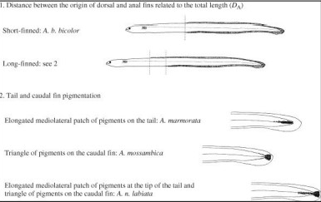

Appendix 3. Ege, (1939) Fin index identification key for tropical juvenile anguillid eels
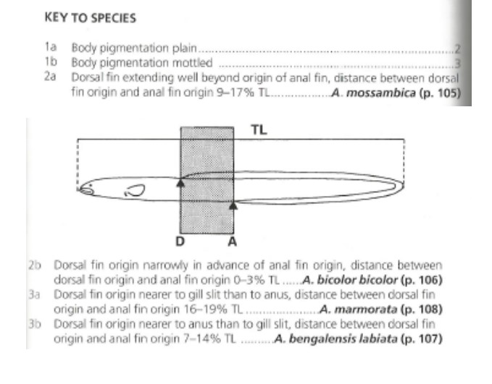

Appendix 4. FDI for every individual captured
 | Family | TL (cm) | DF to AF (mm) | LH (mm) | RH (mm) | Site | Total_Length | FDI | LH_Index | RH_Index
Anguilla mossambica | Anguillidae | 5.4 | 135.296 | 54.384 | 50.7730 | SBE2 | 54000 | 0.25054815 | 0.10071111 | 0.09402407
Anguilla bengalensis | Anguillidae | 5.3 | 102.019 | 72.547 | 64.6770 | SBE2 | 53000 | 0.19248868 | 0.13688113 | 0.12203208
Anguilla bengalensis | Anguillidae | 5.7 | 153.960 | 57.157 | 62.7070 | SBE4 | 57000 | 0.27010526 | 0.10027544 | 0.11001228
Anguilla marmorata | Anguillidae | 5.0 | 130.894 | 71.072 | 66.3740 | SBE4 | 50000 | 0.26178800 | 0.14214400 | 0.13274800
Anguilla mossambica | Anguillidae | 5.2 | 107.439 | 70.345 | 65.8150 | SBE4 | 52000 | 0.20661346 | 0.13527885 | 0.12656731
Anguilla mossambica | Anguillidae | 10.1 | 137.570 | 92.985 | 95.8040 | SBE3 | 101000 | 0.13620792 | 0.09206436 | 0.09485545
Anguilla bengalensis | Anguillidae | 5.6 | 109.694 | 68.126 | 66.5270 | SBE1 | 56000 | 0.19588214 | 0.12165357 | 0.11879821
Anguilla bengalensis | Anguillidae | 5.3 | 119.019 | 66.393 | 64.5830 | SBE2 | 53000 | 0.22456415 | 0.12526981 | 0.12185472
Anguilla mossambica | Anguillidae | 5.7 | 216.262 | 70.842 | 65.7850 | SBE3 | 57000 | 0.37940702 | 0.12428421 | 0.11541228
Anguilla mossambica | Anguillidae | 5.7 | 66.506 | 70.284 | 67.2570 | SBE4 | 57000 | 0.11667719 | 0.12330526 | 0.11799474
Anguilla bengalensis | Anguillidae | 5.5 | 112.257 | 68.994 | 65.6789 | SBE4 | 55000 | 0.20410364 | 0.12544364 | 0.11941618
Anguilla mossambica | Anguillidae | 4.9 | 90.696 | 62.796 | 61.2160 | SBE4 | 49000 | 0.18509388 | 0.12815510 | 0.12493061
Anguilla bengalensis | Anguillidae | 5.4 | 199.379 | 74.686 | 66.3740 | SBE2 | 54000 | 0.36922037 | 0.13830741 | 0.12291481
Anguilla bengalensis | Anguillidae | 5.3 | 117.628 | 67.894 | 63.9780 | SBE2 | 53000 | 0.22193962 | 0.12810189 | 0.12071321
Anguilla bengalensis | Anguillidae | 5.6 | 108.159 | 69.458 | 65.7480 | SBE3 | 56000 | 0.19314107 | 0.12403214 | 0.11740714
Anguilla mossambica | Anguillidae | 5.3 | 86.908 | 69.139 | 59.7150 | SBE3 | 53000 | 0.16397736 | 0.13045094 | 0.11266981
Anguilla bengalensis | Anguillidae | 4.9 | 114.303 | 67.289 | 57.1500 | SBE3 | 49000 | 0.23327143 | 0.13732449 | 0.11663265
Anguilla mossambica | Anguillidae | 5.3 | 48.365 | 63.479 | 59.0220 | SBE3 | 53000 | 0.09125472 | 0.11977170 | 0.11136226
Anguilla bengalensis | Anguillidae | 4.6 | 74.818 | 61.216 | 57.4780 | SBE1 | 46000 | 0.16264783 | 0.13307826 | 0.12495217
Anguilla bengalensis | Anguillidae | 5.3 | 123.955 | 69.561 | 55.9420 | SBE1 | 53000 | 0.23387736 | 0.13124717 | 0.10555094
Anguilla mossambica | Anguillidae | 5.1 | 157.948 | 64.305 | 66.6090 | SBE1 | 51000 | 0.30970196 | 0.12608824 | 0.13060588
Anguilla bengalensis | Anguillidae | 5.3 | 163.993 | 64.252 | 61.9720 | SBE1 | 53000 | 0.30942075 | 0.12123019 | 0.11692830
Anguilla bengalensis | Anguillidae | 4.9 | 114.110 | 80.276 | 81.6150 | SBE1 | 49000 | 0.23287755 | 0.16382857 | 0.16656122
Anguilla bengalensis | Anguillidae | 5.3 | 146.701 | 61.211 | 66.5190 | SBE2 | 53000 | 0.27679434 | 0.11549245 | 0.12550755
Anguilla bengalensis | Anguillidae | 5.4 | 93.101 | 61.986 | 64.3940 | SBE2 | 54000 | 0.17240926 | 0.11478889 | 0.11924815
Anguilla bengalensis | Anguillidae | 6.5 | 170.848 | 55.016 | 54.2630 | SBE2 | 65000 | 0.26284308 | 0.08464000 | 0.08348154
Anguilla mossambica | Anguillidae | 5.1 | 173.070 | 62.253 | 63.8420 | SBE2 | 51000 | 0.33935294 | 0.12206471 | 0.12518039
Anguilla bengalensis | Anguillidae | 5.2 | 108.862 | 67.295 | 60.4750 | SBE2 | 52000 | 0.20935000 | 0.12941346 | 0.11629808
Anguilla bengalensis | Anguillidae | 5.4 | 120.158 | 58.194 | 59.7430 | SBE4 | 54000 | 0.22251481 | 0.10776667 | 0.11063519
Anguilla bengalensis | Anguillidae | 5.2 | 151.903 | 61.967 | 57.5570 | SBE4 | 52000 | 0.29212115 | 0.11916731 | 0.11068654
Anguilla bengalensis | Anguillidae | 5.6 | 114.906 | 57.433 | 49.9680 | SBE4 | 56000 | 0.20518929 | 0.10255893 | 0.08922857
Anguilla mossambica | Anguillidae | 5.0 | 1400.568 | 398.128 | 398.0010 | SBE4 | 50000 | 2.80113600 | 0.79625600 | 0.79600200
Anguilla mossambica | Anguillidae | 11.0 | 507.831 | 94.483 | 103.1740 | SBE4 | 110000 | 0.46166455 | 0.08589364 | 0.09379455
Anguilla mossambica | Anguillidae | 9.8 | 322.101 | 107.988 | 102.7750 | SBE4 | 98000 | 0.32867449 | 0.11019184 | 0.10487245
Anguilla bengalensis | Anguillidae | 7.5 | 202.527 | 77.214 | 78.7230 | SBE2 | 75000 | 0.27003600 | 0.10295200 | 0.10496400
Anguilla bengalensis | Anguillidae | 5.2 | 152.000 | 63.897 | 58.8410 | SBE4 | 52000 | 0.29230769 | 0.12287885 | 0.11315577
Anguilla marmorata | Anguillidae | 5.4 | 119.394 | 57.892 | 58.6510 | SBE4 | 54000 | 0.22110000 | 0.10720741 | 0.10861296
Anguilla bengalensis | Anguillidae | 5.1 | 111.656 | 67.310 | 74.2280 | SBE4 | 51000 | 0.21893333 | 0.13198039 | 0.14554510
Anguilla bengalensis | Anguillidae | 5.1 | 113.351 | 61.820 | 70.0600 | SBE4 | 51000 | 0.22225686 | 0.12121569 | 0.13737255
Anguilla mossambica | Anguillidae | 5.1 | 203.128 | 63.609 | 65.4710 | SBE4 | 51000 | 0.39829020 | 0.12472353 | 0.12837451
Anguilla mossambica | Anguillidae | 7.3 | 234.271 | 77.096 | 65.2710 | SBE3 | 73000 | 0.32091918 | 0.10561096 | 0.08941233
Anguilla bengalensis | Anguillidae | 7.3 | 59.719 | 59.719 | 53.6760 | SBE3 | 73000 | 0.08180685 | 0.08180685 | 0.07352877
Anguilla mossambica | Anguillidae | 7.6 | 226.207 | 51.627 | 40.5680 | SBE3 | 76000 | 0.29764079 | 0.06793026 | 0.05337895
Anguilla bengalensis | Anguillidae | 6.8 | 105.586 | 58.079 | 55.3370 | SBE1 | 68000 | 0.15527353 | 0.08541029 | 0.08137794
Anguilla bengalensis | Anguillidae | 5.3 | 111.683 | 70.151 | 54.3920 | SBE1 | 53000 | 0.21072264 | 0.13236038 | 0.10262642
Anguilla mossambica | Anguillidae | 5.6 | 195.599 | 40.158 | 42.4110 | SBE1 | 56000 | 0.34928393 | 0.07171071 | 0.07573393
Anguilla mossambica | Anguillidae | 5.4 | 283.743 | 45.317 | 51.6190 | SBE1 | 54000 | 0.52545000 | 0.08392037 | 0.09559074
Anguilla mossambica | Anguillidae | 5.3 | 441.158 | 50.731 | 57.1790 | SBE1 | 53000 | 0.83237358 | 0.09571887 | 0.10788491
Anguilla bengalensis | Anguillidae | 5.0 | 269.606 | 45.176 | 42.4110 | SBE1 | 50000 | 0.53921200 | 0.09035200 | 0.08482200
Anguilla bengalensis | Anguillidae | 5.3 | 126.479 | 65.504 | 58.3740 | SBE1 | 53000 | 0.23863962 | 0.12359245 | 0.11013962
Anguilla bengalensis | Anguillidae | 5.5 | 211.489 | 62.680 | 54.3920 | SBE4 | 55000 | 0.38452545 | 0.11396364 | 0.09889455
Anguilla bengalensis | Anguillidae | 5.3 | 130.439 | 63.609 | 50.7060 | SBE4 | 53000 | 0.24611132 | 0.12001698 | 0.09567170
Anguilla bengalensis | Anguillidae | 5.4 | 104.209 | 57.157 | 52.5410 | SBE4 | 54000 | 0.19297963 | 0.10584630 | 0.09729815
Anguilla mossambica | Anguillidae | 7.4 | 176.840 | 86.269 | 72.5630 | SBE4 | 74000 | 0.23897297 | 0.11657973 | 0.09805811
Anguilla bengalensis | Anguillidae | 5.6 | 106.553 | 79.406 | 72.5470 | SBE4 | 56000 | 0.19027321 | 0.14179643 | 0.12954821
Anguilla bengalensis | Anguillidae | 4.8 | 115.632 | 59.777 | 61.2530 | SBE1 | 48000 | 0.24090000 | 0.12453542 | 0.12761042
Anguilla bengalensis | Anguillidae | 5.3 | 142.272 | 58.194 | 55.1710 | SBE1 | 53000 | 0.26843774 | 0.10980000 | 0.10409623
Anguilla bengalensis | Anguillidae | 5.4 | 83.142 | 61.972 | 63.5190 | SBE1 | 54000 | 0.15396667 | 0.11476296 | 0.11762778
Anguilla bengalensis | Anguillidae | 4.8 | 36.305 | 59.719 | 52.8990 | SBE2 | 48000 | 0.07563542 | 0.12441458 | 0.11020625
Anguilla bengalensis | Anguillidae | 5.5 | 170.059 | 59.700 | 57.8340 | SBE2 | 55000 | 0.30919818 | 0.10854545 | 0.10515273
Anguilla bengalensis | Anguillidae | 5.2 | 126.966 | 71.827 | 65.0300 | SBE2 | 52000 | 0.24416538 | 0.13812885 | 0.12505769
Anguilla bengalensis | Anguillidae | 5.4 | 123.944 | 68.831 | 73.3140 | SBE2 | 54000 | 0.22952593 | 0.12746481 | 0.13576667
Anguilla bengalensis | Anguillidae | 5.3 | 129.304 | 53.660 | 62.1930 | SBE1 | 53000 | 0.24396981 | 0.10124528 | 0.11734528
Anguilla bengalensis | Anguillidae | 5.0 | 102.019 | 67.410 | 64.3450 | SBE1 | 50000 | 0.20403800 | 0.13482000 | 0.12869000
Anguilla bengalensis | Anguillidae | 5.3 | 189.075 | 66.519 | 62.0090 | SBE2 | 53000 | 0.35674528 | 0.12550755 | 0.11699811
Anguilla mossambica | Anguillidae | 5.7 | 185.152 | 59.333 | 53.7400 | SBE4 | 57000 | 0.32482807 | 0.10409298 | 0.09428070
Anguilla bengalensis | Anguillidae | 5.6 | 137.545 | 64.252 | 64.2390 | SBE4 | 56000 | 0.24561607 | 0.11473571 | 0.11471250
Anguilla bengalensis | Anguillidae | 5.2 | 157.970 | 62.082 | 53.9940 | SBE2 | 52000 | 0.30378846 | 0.11938846 | 0.10383462
Anguilla bengalensis | Anguillidae | 5.4 | 56.723 | 37.037 | 31.8830 | SBE2 | 54000 | 0.10504259 | 0.06858704 | 0.05904259
Anguilla bengalensis | Anguillidae | 5.4 | 98.252 | 56.677 | 48.5120 | SBE3 | 54000 | 0.18194815 | 0.10495741 | 0.08983704
Anguilla bengalensis | Anguillidae | 5.6 | 77.096 | 54.494 | 55.4190 | SBE3 | 56000 | 0.13767143 | 0.09731071 | 0.09896250
Anguilla mossambica | Anguillidae | 5.4 | 77.841 | 50.722 | 50.6370 | SBE1 | 54000 | 0.14415000 | 0.09392963 | 0.09377222
Anguilla bengalensis | Anguillidae | 5.3 | 69.541 | 57.612 | 57.0840 | SBE1 | 53000 | 0.13120943 | 0.10870189 | 0.10770566
Anguilla bengalensis | Anguillidae | 5.3 | 82.402 | 55.927 | 42.3800 | SBE1 | 53000 | 0.15547547 | 0.10552264 | 0.07996226
Anguilla bengalensis | Anguillidae | 5.3 | 71.354 | 56.785 | 57.9320 | SBE1 | 53000 | 0.13463019 | 0.10714151 | 0.10930566
Anguilla bengalensis | Anguillidae | 5.4 | 116.380 | 60.498 | 54.5990 | SBE1 | 54000 | 0.21551852 | 0.11203333 | 0.10110926

